Software Design Document (SDD)
Module: GPIO Driver
Version: 1.0
Authors: De La Torre Gomez Aldo Sebastian 37969, Cuadros Troncoso Pedro 37795, Garcia Veliz Oskar Liborio 38265

1. Introduction
1.1. Purpose
This document describes the software design and architecture of the GPIO driver module developed for the STM32F411RE microcontroller, as part of the Microcontrollers and Embedded Systems course at CETYS Universidad. The design is based on the requirements defined in SRS-GPIO_Driver v1.0 and provides details on data structures, enumerations, register-level algorithms, and control flow to guide implementation and testing. This SDD also serves as a reference for maintenance, testing, and future improvements of the GPIO Control System firmware.
1.2. Scope
The GPIO driver is a low-level software component for embedded systems. It abstracts hardware registers and provides a clean C API for higher-level modules (led, button) to configure and control digital I/O pins on the STM32F411RE without accessing hardware registers directly. The system performs the following specific operations:
  - Configures GPIOA pin 5 (PA5) as digital output for LED control (onboard LED LD2).
  - Configures GPIOC pin 13 (PC13) as digital input for user button reading (onboard button B1).
  - Enables and manages peripheral clocks via the RCC AHB1ENR register.
  - Detects user button presses with software debounce logic.
  - Toggles the onboard LED state on each confirmed button press.
  - Uses modular firmware architecture: gpio_driver, led, button, and main modules.
  - Does not depend on HAL libraries — all hardware interaction uses direct MCU register access.
1.3. Definitions and Acronyms
Term | Definition
GPIO | General Purpose Input/Output
Port | A collection of up to 16 GPIO pins grouped under one peripheral (e.g., GPIOA, GPIOC)
Pin | A single digital input/output line within a port (numbered 0-15)
RCC | Reset and Clock Control - enables GPIO port clocks via AHB1ENR register
MODER | GPIO Mode Register - input(00), output(01), alt function(10), analog(11)
BSRR | Bit Set/Reset Register - atomic set bits[15:0] and clear bits[31:16]
ODR | Output Data Register - current driven output state of each pin
IDR | Input Data Register - current logic level on each pin
PUPDR | Pull-Up/Pull-Down Register - internal pull resistors per pin
AFR | Alternate Function Register - AFR[0] pins 0-7, AFR[1] pins 8-15
FR-x | Functional Requirement x - defined in SRS-GPIO_Driver v1.0
NFR-x | Non-Functional Requirement x - defined in SRS-GPIO_Driver v1.0
HAL | Hardware Abstraction Layer - NOT used; driver uses direct register access
CMSIS | Cortex Microcontroller Software Interface Standard - provides GPIO_TypeDef/RCC_TypeDef
MCU | Microcontroller Unit — refers to the STM32F411RE in this document
LED | Light Emitting Diode — refers to the onboard green LED LD2 connected to PA5
API | Application Programming Interface — the public function set exposed by each driver module
OTYPER | Output Type Register — selects push-pull (0) or open-drain (1) per pin
OSPEEDR | Output Speed Register — controls output slew rate per pin
1.4. Requirements
All requirements for this module are allocated in SRS-GPIO_Driver v1.0, available in the project GitHub repository. This document covers FR-1 through FR-8 (functional) and NFR-1 through NFR-3 (non-functional).

2. System Architecture
2.1. High-Level Design
- Layered Architecture:
  - Application Layer: Contains main.c, responsible for calling driver modules and executing the main control loop. Initializes GPIO system, LED, and button modules at startup, then enters an infinite loop that reads button state and toggles the LED on each confirmed press.
  - Peripheral Module Layer: Contains reusable firmware modules: LED Driver (led.c / led.h) responsible for initializing PA5 as output and controlling LED on/off/toggle state; and Button Driver (button.c / button.h) responsible for configuring PC13 as input and detecting button press state with software debounce. Both modules use only the GPIO driver API.
  - GPIO Driver Layer: Contains gpio_driver.c / gpio_driver.h. The only layer that accesses STM32F411RE GPIO registers (MODER, BSRR, ODR, IDR, PUPDR, OSPEEDR, OTYPER, AFR) and RCC clock registers. Provides a clean, validated C API to all upper layers (NFR-1, NFR-2, NFR-3).
  - Hardware Layer: STM32F411RE GPIO peripheral registers and RCC, accessed through CMSIS GPIO_TypeDef and RCC_TypeDef structs from stm32f4xx.h. Not directly visible to any layer above the GPIO driver.
2.2. Module Interfaces
- Public API: Functions declared in the following header files with their respective prefixes: gpio_driver.h (gpio_ prefix), led.h (led_ prefix), button.h (button_ prefix). All public GPIO driver functions except gpio_init() return GPIO_Status_t for error propagation.
- Dependencies: stm32f4xx.h (CMSIS device header providing GPIO_TypeDef, RCC_TypeDef, and peripheral base addresses), stdint.h, and the ARM Cortex-M4 architecture definitions. No HAL, LL, or vendor middleware required (NFR-1).
- Internal Functions: prv_getPort and prv_validate - declared static in gpio_driver.c, not part of the public API.

3. Detailed Design
3.1. Module Description
A. GPIO Driver Module (gpio_driver.c / gpio_driver.h)
Responsible for generic GPIO configuration and control. Provides the complete low-level register abstraction for all GPIO operations on the STM32F411RE. Responsibilities: enable GPIO peripheral clocks via RCC AHB1ENR; configure pin modes (input, output, alternate function, analog) via MODER; control output state atomically via BSRR; read input state from IDR; configure alternate function registers (AFR); and validate all arguments returning GPIO_Status_t error codes.
B. LED Driver Module (led.c / led.h)
Responsible for controlling the onboard green LED connected to GPIOA pin 5 (PA5). Uses only GPIO driver API — never accesses hardware registers directly. Responsibilities: initialize PA5 as push-pull output at low speed with no pull resistor via gpio_setPinMode(); turn LED ON via gpio_setPin(); turn LED OFF via gpio_clearPin(); toggle LED state via gpio_togglePin().
C. Button Driver Module (button.c / button.h)
Responsible for reading the onboard user push-button connected to GPIOC pin 13 (PC13). The button uses active-low logic — the Nucleo-64 board provides an external pull-up on PC13, so the pin reads HIGH when idle and LOW when pressed. Responsibilities: configure PC13 as floating input via gpio_setPinMode(); detect button press state using a 20-sample majority-vote debounce algorithm via gpio_readPin(); return BUTTON_PRESSED or BUTTON_RELEASED.
D. Main Application (main.c)
Coordinates all modules and implements the main control loop. Never accesses hardware registers directly. Operation flow: (1) Call gpio_init() to enable all GPIO clocks; (2) Call led_init() to configure PA5 as output, LED starts OFF; (3) Call button_init() to configure PC13 as input; (4) Enter infinite loop — read button_get_state(); if BUTTON_PRESSED for 3 consecutive iterations (DEBOUNCE=3), call led_toggle(); wait for BUTTON_RELEASED before next detection.
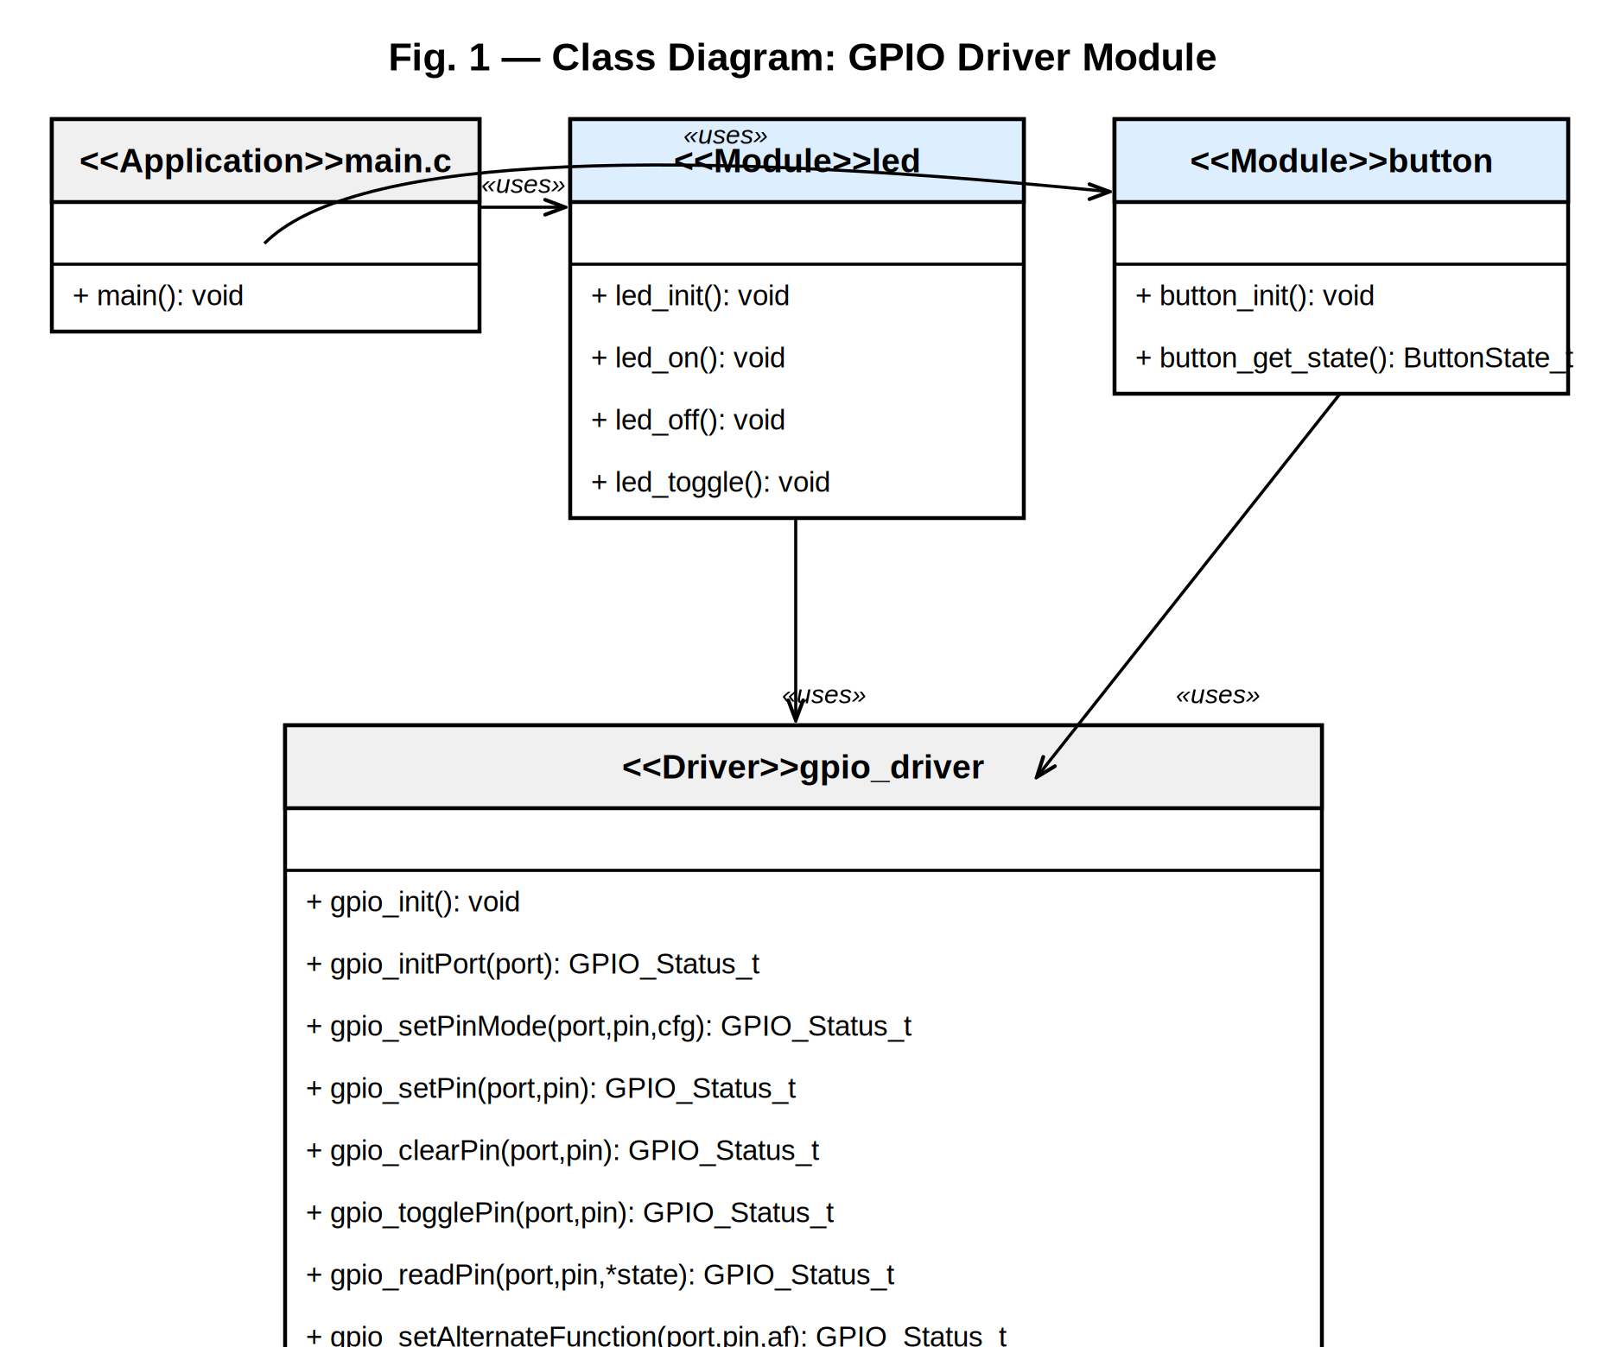
Fig. 1 — Class Diagram: GPIO Driver Module
Class diagram showing the four software components of the GPIO Control System and their dependency relationships. The gpio_driver is the only class that accesses hardware registers directly. All other modules depend on it through well-defined public API calls.
As shown in Fig. 1, the class diagram captures the four main software components and their relationships. main.c depends on both the led and button modules, which in turn depend exclusively on gpio_driver. The gpio_driver is the only class that accesses the Hardware Layer — the STM32F411RE GPIO peripheral registers. This strict top-down dependency chain ensures that no application code ever reaches a hardware register directly, and that changing the underlying hardware only requires modifying the GPIO driver without touching any other module. The two private methods prv_validate() and prv_getPort() are shown with a minus sign prefix, indicating they are not part of the public API.

3.2. Module Behavior
Initial State
After calling gpio_init(), led_init(), and button_init(), the system starts in a known safe state: LED is OFF (PA5 driven LOW via gpio_clearPin()), button is configured as floating input (PC13 with external pull-up HIGH), and the debounce counter is zero.
Event: Button Pressed
When the user presses the button, PC13 is pulled LOW. The main loop calls button_get_state(), which performs 20 consecutive IDR samples. If more than 10 samples read LOW (majority-vote), BUTTON_PRESSED is returned. The main loop increments a confirmation counter; when it reaches DEBOUNCE=3, led_toggle() is called, inverting PA5 via gpio_togglePin() (ODR XOR). The LED changes state from OFF to ON or ON to OFF.
Event: Button Released
When the button is released, PC13 returns HIGH. button_get_state() returns BUTTON_RELEASED and the confirmation counter resets to zero. The main loop waits for a full new sequence of confirmed presses before toggling again, preventing multiple unintended toggles from a single physical press event.
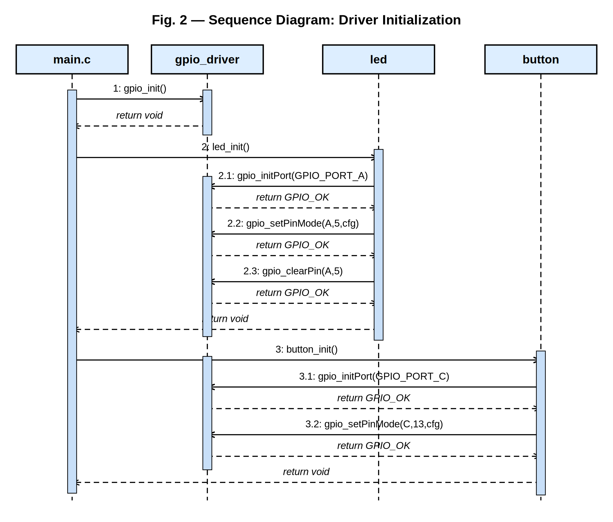
Fig. 2 — Sequence Diagram: Driver Initialization
Sequence diagram showing the ordered call chain during system startup. main.c calls gpio_init(), then led_init() — which internally calls gpio_initPort() and gpio_setPinMode() — and finally button_init(), which repeats the same GPIO driver calls for port GPIOC.
Fig. 2 shows the message sequence during the three-step initialization phase. The caller is always main.c, which orchestrates the startup without knowing any hardware details. The first message is gpio_init(), which returns immediately (void). Then led_init() triggers a cascade of three internal GPIO driver calls: gpio_initPort(PORT_A) to enable the GPIOA clock, gpio_setPinMode(A, 5, cfg) to configure PA5 as push-pull output, and gpio_clearPin(A, 5) to ensure the LED starts OFF. The same pattern repeats for button_init(), which calls gpio_initPort(PORT_C) and gpio_setPinMode(C, 13, cfg) to configure PC13 as floating input. Activation boxes on each lifeline show the time each object is actively executing.
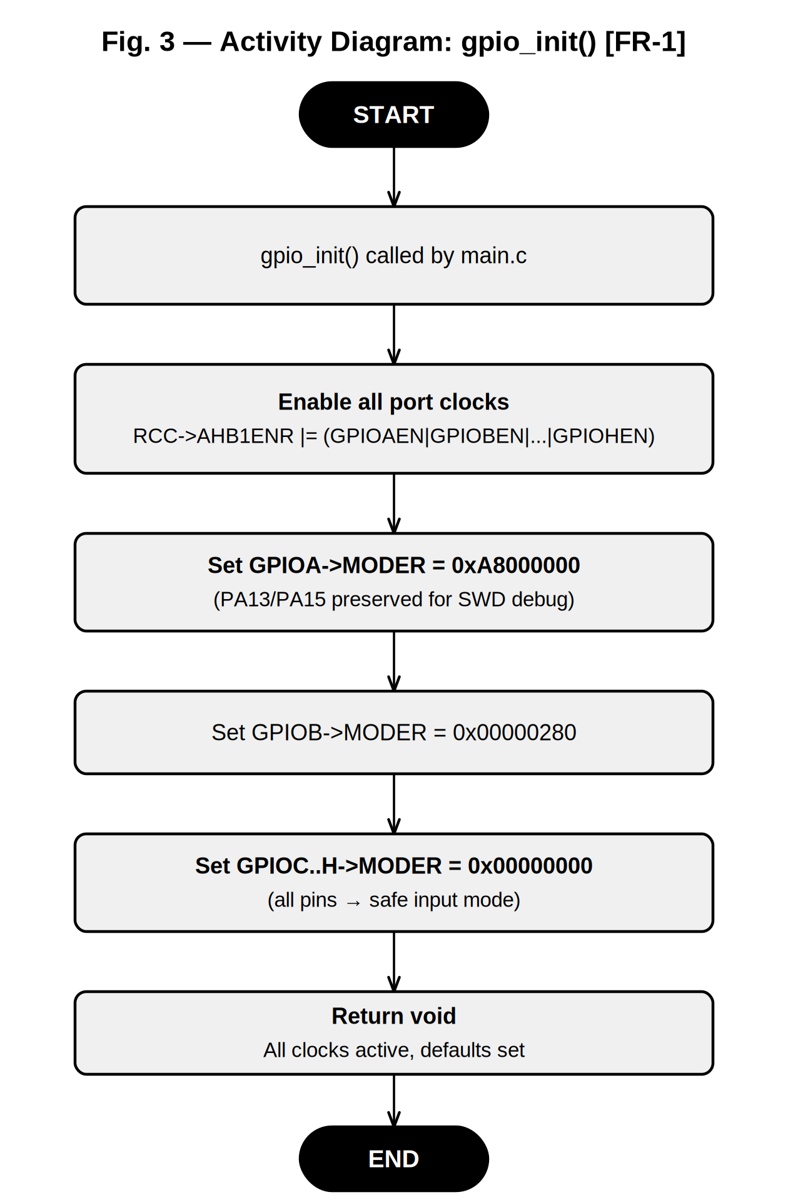
Fig. 3 — Activity Diagram: gpio_init() [FR-1]
Activity diagram detailing the sequential steps of gpio_init(). The function enables all six GPIO port clocks in a single register write, then sets each port's MODER register to its RM0383 post-reset default value before returning.
Fig. 3 details the internal activity flow of gpio_init(). The function begins by enabling the peripheral clocks for all six GPIO ports (A through H) simultaneously using a single OR-write to RCC->AHB1ENR. It then sets the MODER register of each port to its hardware reset default: GPIOA receives 0xA8000000, which preserves the alternate function mode of the PA13 and PA15 pins used by the SWD debug interface; GPIOB receives 0x00000280; and all remaining ports receive 0x00000000, placing all pins in safe input mode. Because the function always succeeds at the hardware level it returns void and requires no error handling by the caller.
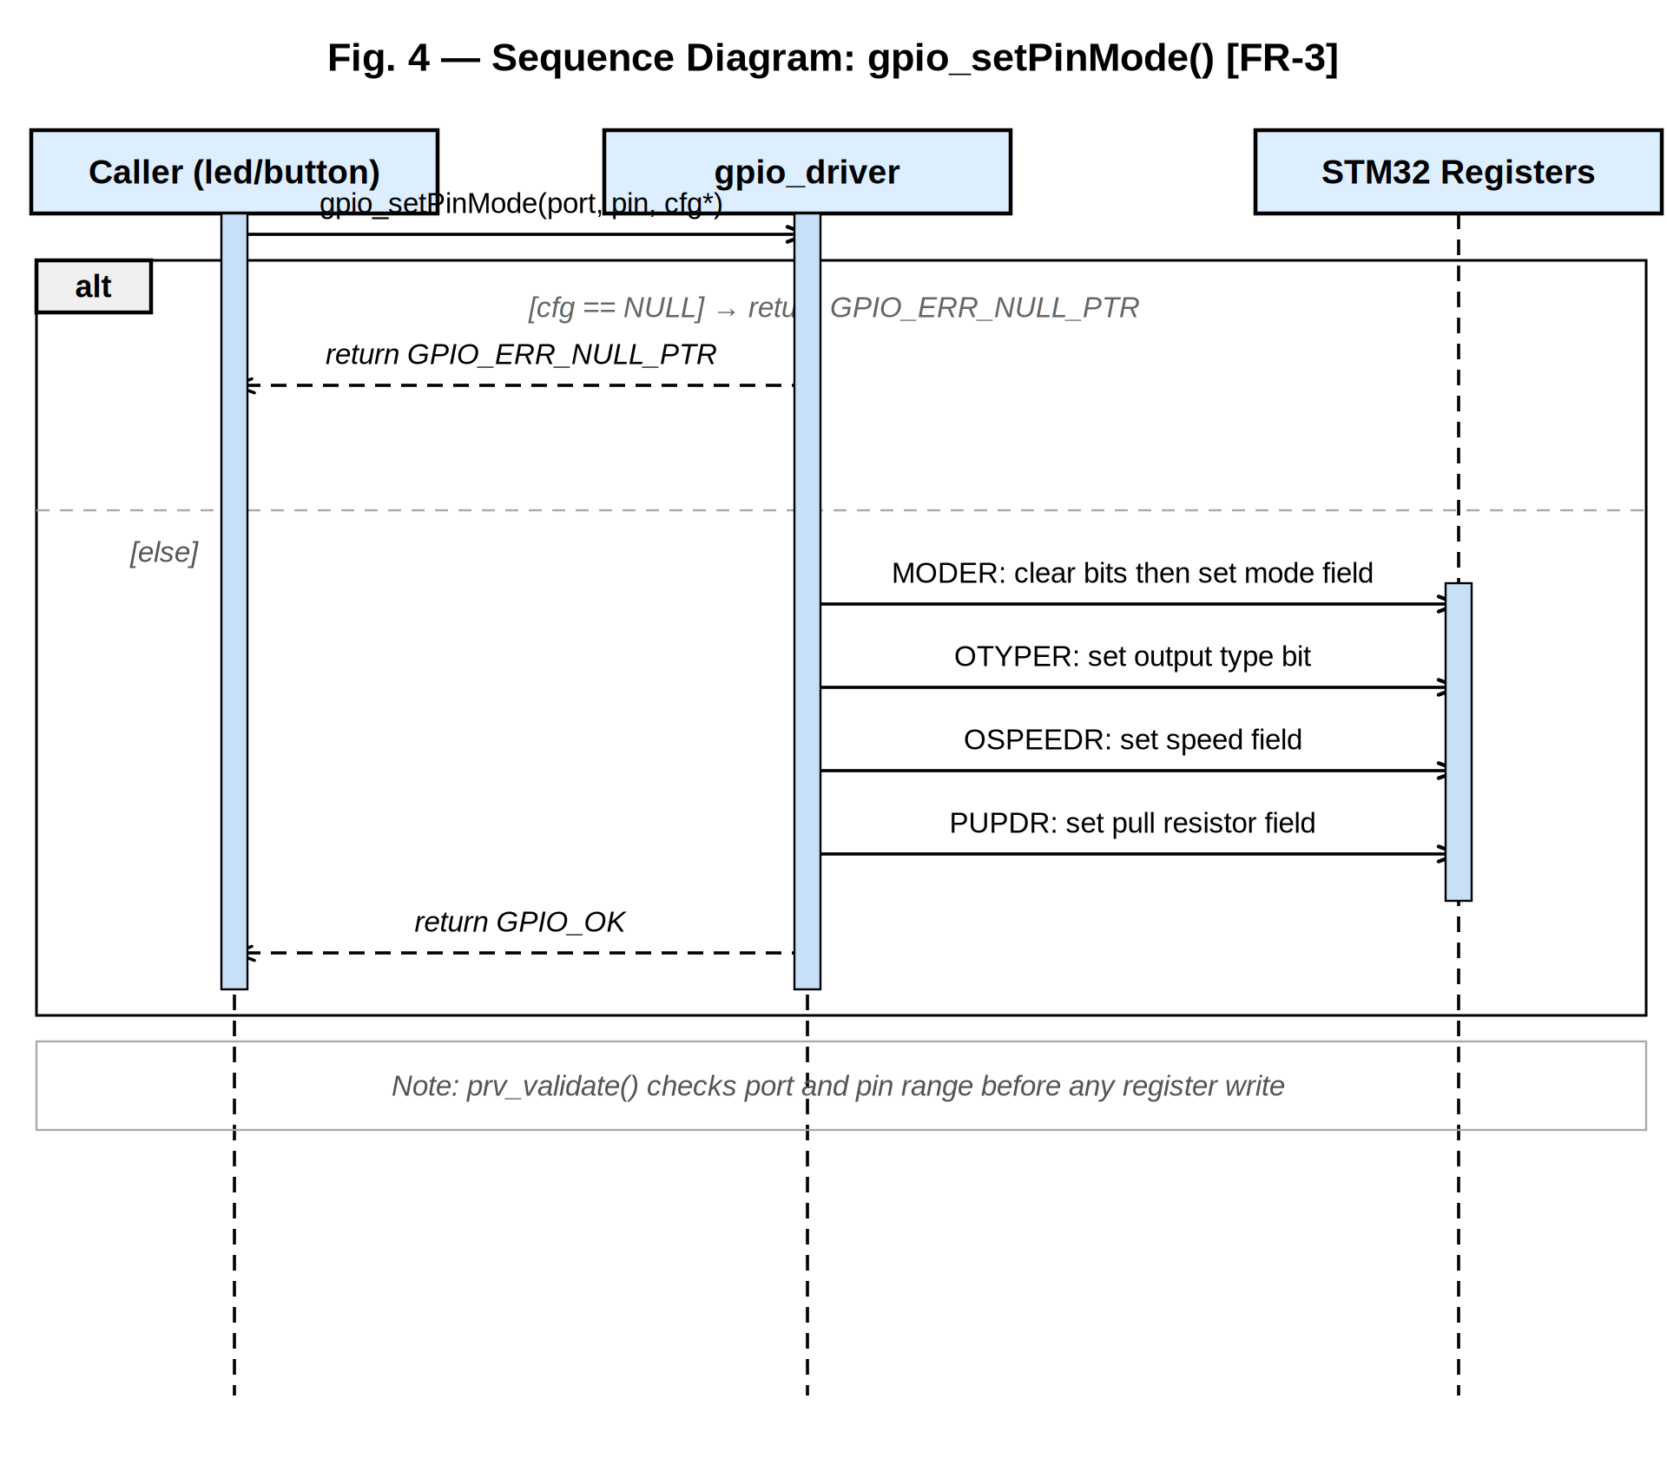
Fig. 4 — Sequence Diagram: gpio_setPinMode() with Conditional [FR-3]
Sequence diagram for gpio_setPinMode() showing the two execution paths: the alternative (alt) fragment on the left handles the NULL pointer and invalid argument cases, while the normal path shows the four sequential register writes to MODER, OTYPER, OSPEEDR, and PUPDR.
Fig. 4 uses a UML alt combined fragment to show the conditional branching inside gpio_setPinMode(). The upper guard [cfg == NULL] represents the early-exit path that returns GPIO_ERR_NULL_PTR immediately without touching any hardware register. The lower [else] guard represents the normal path, where the driver sends four sequential write messages to the STM32 registers: MODER for pin direction, OTYPER for output type, OSPEEDR for slew rate, and PUPDR for pull resistor. Each write uses a read-clear-set pattern on only the two bits belonging to the target pin, leaving all other pins in the same port unaffected. The note at the bottom indicates that prv_validate() checks port and pin range before any of these register accesses occur.
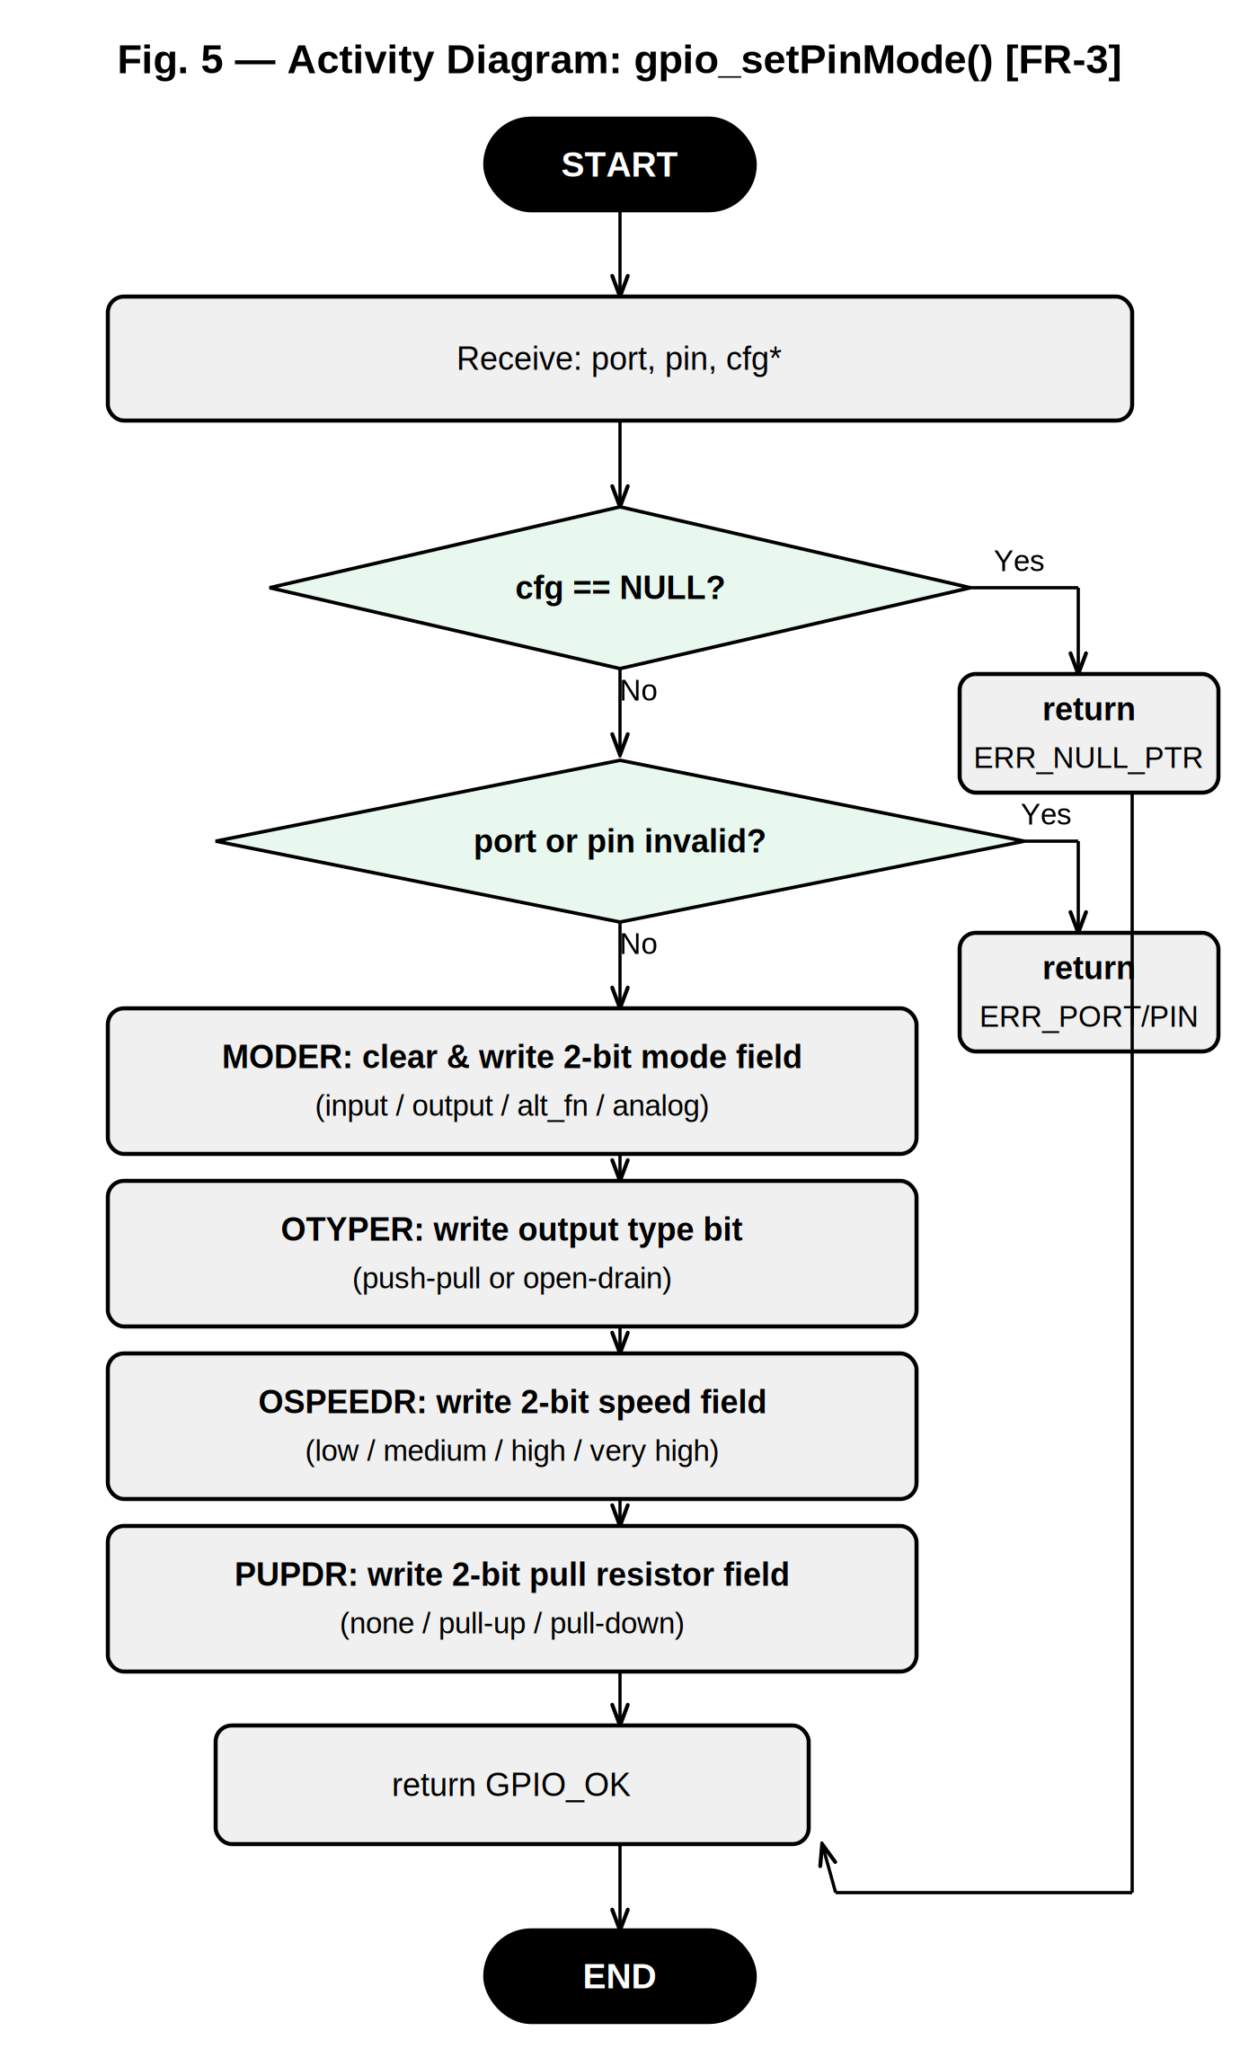
Fig. 5 — Activity Diagram: gpio_setPinMode() with Conditional [FR-3]
Activity diagram for gpio_setPinMode() showing the two decision guards for argument validation followed by the four sequential register configuration steps. Error paths from both decision nodes converge on the right and return to the caller.
Fig. 5 complements the sequence diagram of Fig. 4 by showing the full activity flow of gpio_setPinMode() as a flowchart. Two decision nodes appear at the top: the first checks whether the cfg pointer is NULL, and the second checks whether the port or pin arguments are out of range. Both error paths merge on the right side and return the appropriate error code to the caller, satisfying NFR-2. If both validations pass, the function proceeds through four sequential activity nodes — one for each register field — showing that MODER, OTYPER, OSPEEDR, and PUPDR are always written in that fixed order. The activity ends with a return of GPIO_OK.
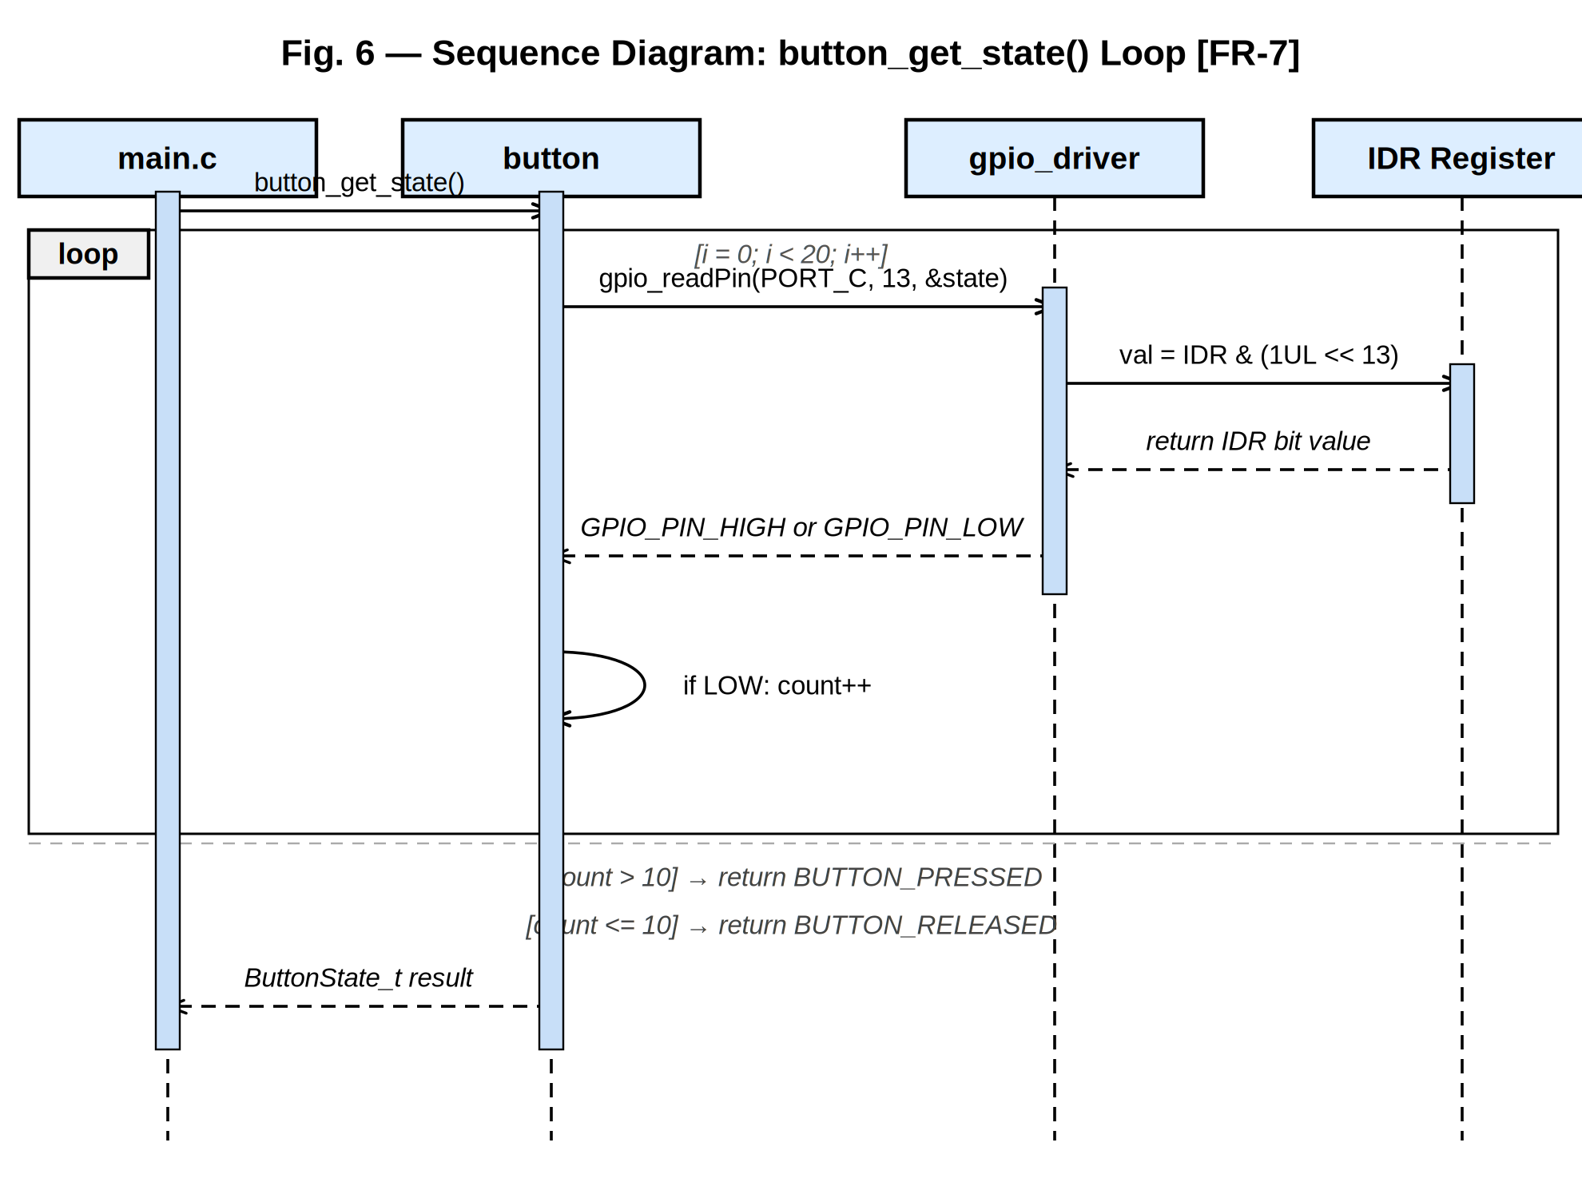
Fig. 6 — Sequence Diagram: button_get_state() with Loop
Sequence diagram for button_get_state() showing the loop combined fragment that repeats gpio_readPin() 20 times. After the loop, a guard evaluates whether more than 10 samples read LOW and returns BUTTON_PRESSED or BUTTON_RELEASED accordingly.
Fig. 6 uses a UML loop combined fragment to model the majority-vote debounce algorithm inside button_get_state(). The loop guard [i = 0; i < 20; i++] indicates that gpio_readPin(PORT_C, 13, &state) is called 20 consecutive times. On each iteration the driver reads the IDR register and returns either GPIO_PIN_HIGH or GPIO_PIN_LOW. The button module increments a local counter each time a LOW sample is received. After the loop exits, a guard evaluates [count > 10] — if more than half the samples read LOW, the function returns BUTTON_PRESSED; otherwise it returns BUTTON_RELEASED. This statistical approach is immune to the short bounce transients that occur in the first few milliseconds after a physical button press.
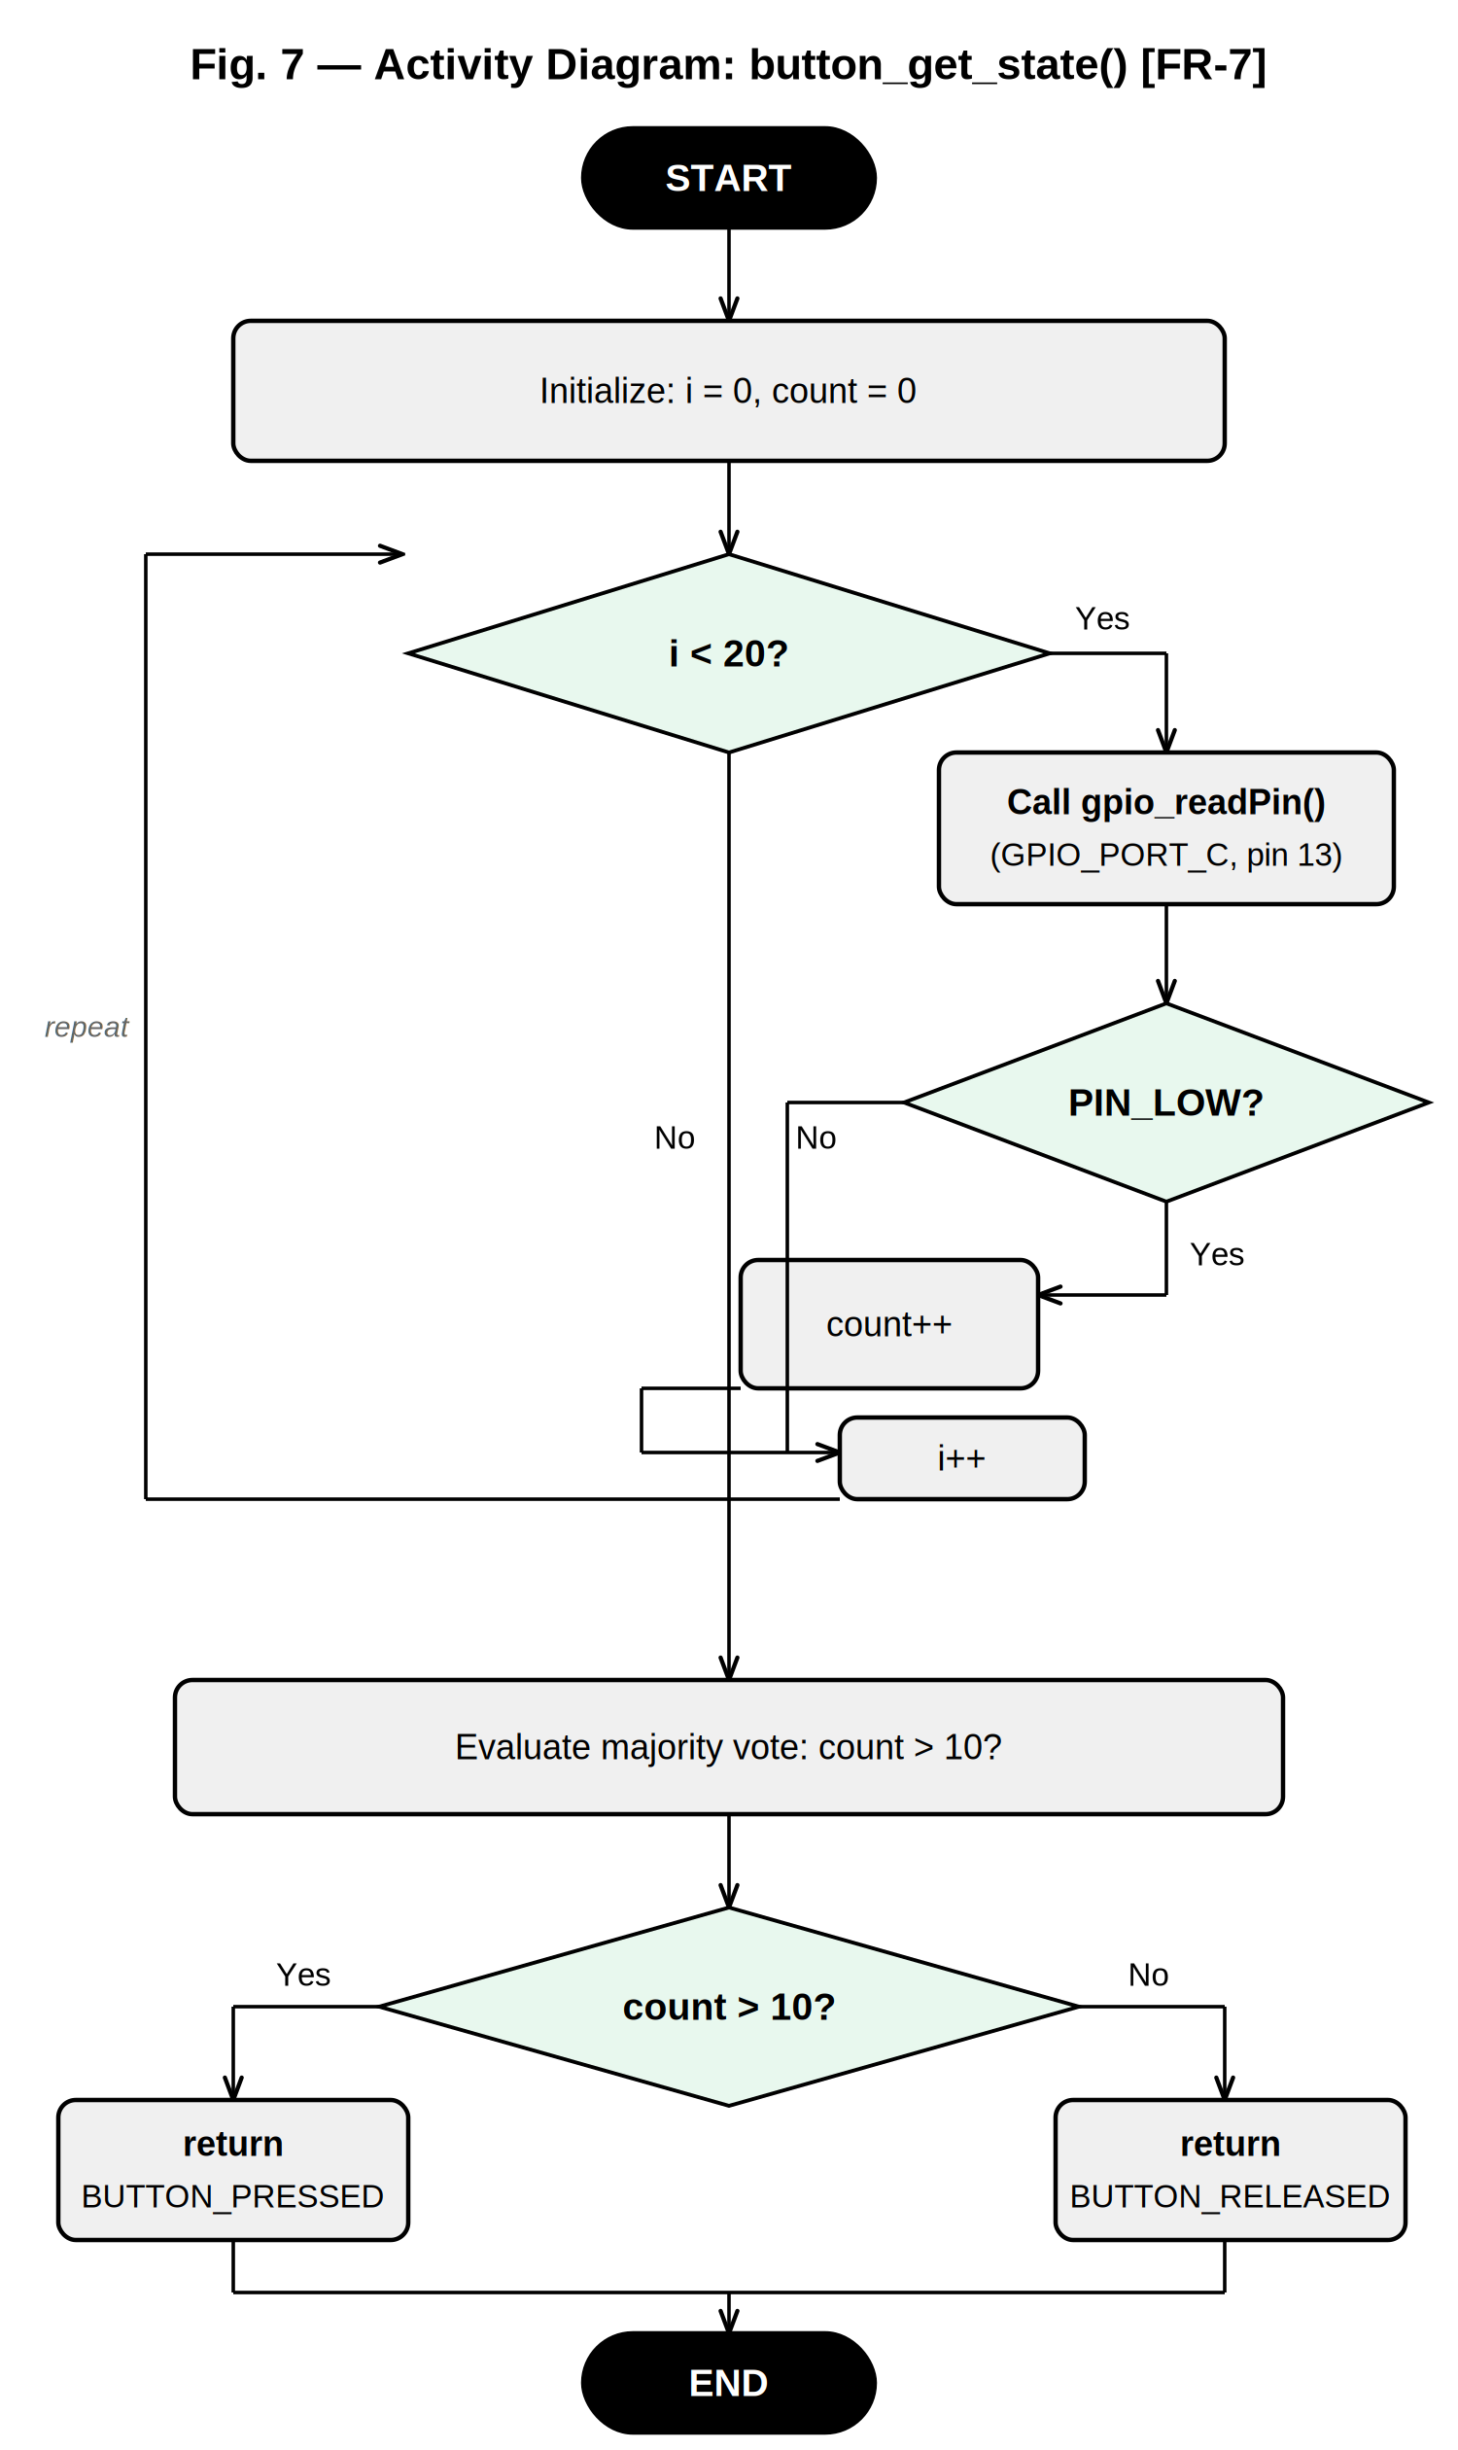
Fig. 7 — Activity Diagram: button_get_state() with Loop
Activity diagram for button_get_state() detailing the 20-iteration majority-vote loop. Each iteration calls gpio_readPin() and conditionally increments a counter. After the loop, a final decision node determines the return value based on whether more than 10 samples read LOW.
Fig. 7 provides the activity-level view of the debounce loop shown sequentially in Fig. 6. The loop decision node [i < 20?] drives 20 iterations. Inside each iteration, the result of gpio_readPin(PORT_C, 13) is evaluated: if the pin reads LOW (button pressed), the counter is incremented; otherwise the iteration ends and i is incremented. The loop back-arrow on the left side of the diagram makes the repetition structure explicit. After all 20 iterations, the final decision node evaluates [count > 10] and routes execution to either the BUTTON_PRESSED or BUTTON_RELEASED return path. Both paths merge before the END node.
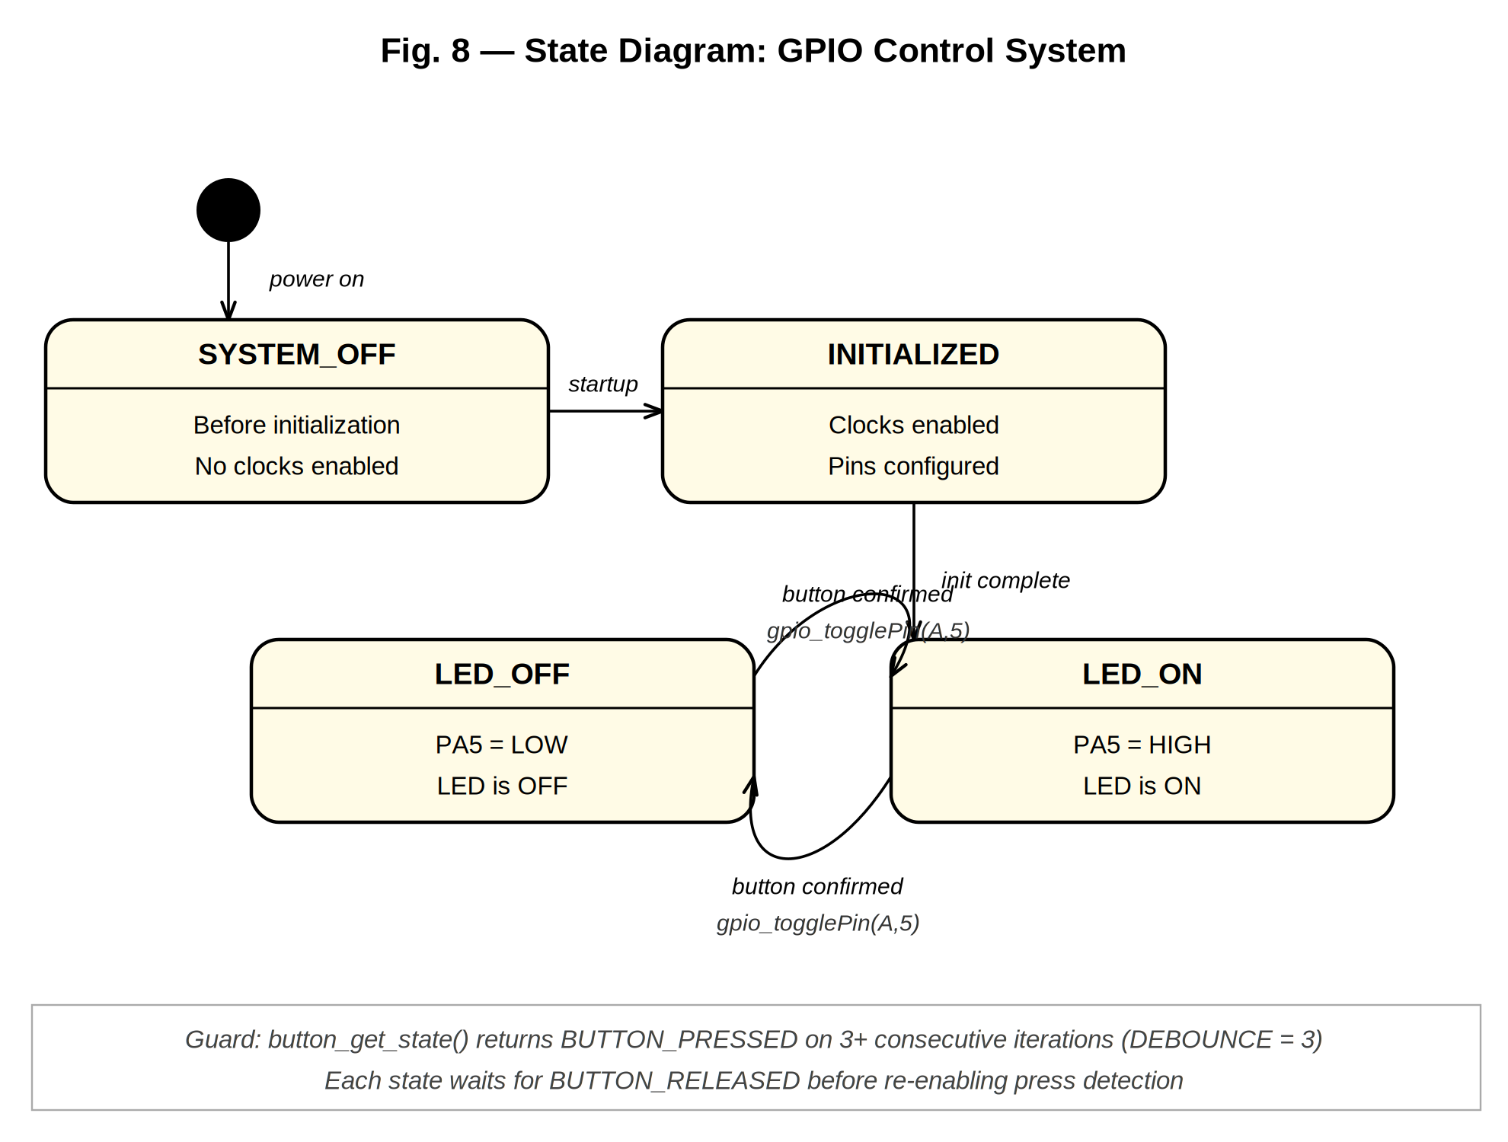
Fig. 8 — State Diagram: GPIO Control System
State diagram of the GPIO Control System showing the four system states and the transitions triggered by initialization and button presses. The LED_OFF and LED_ON states form a toggle cycle guarded by the two-layer debounce condition.
Fig. 8 captures the runtime behavior of the entire GPIO Control System as a state machine. The system begins in the SYSTEM_OFF state before any initialization is called. The startup sequence (gpio_init(), led_init(), button_init()) moves the system into the INITIALIZED state. Once all modules are configured, the system transitions into the LED_OFF state, where PA5 is driven LOW and the LED is dark. A confirmed button press — defined by the debounce guard requiring button_get_state() to return BUTTON_PRESSED on at least 3 consecutive loop iterations — triggers a call to gpio_togglePin(GPIO_PORT_A, 5), which transitions the system to LED_ON. A subsequent confirmed press toggles back to LED_OFF. Both states wait internally for BUTTON_RELEASED before re-enabling press detection, preventing repeated toggles from a single sustained press.
3.2.1. Per-Function Sequence and Activity Diagrams

gpio_init() — FR-1: System Initialization
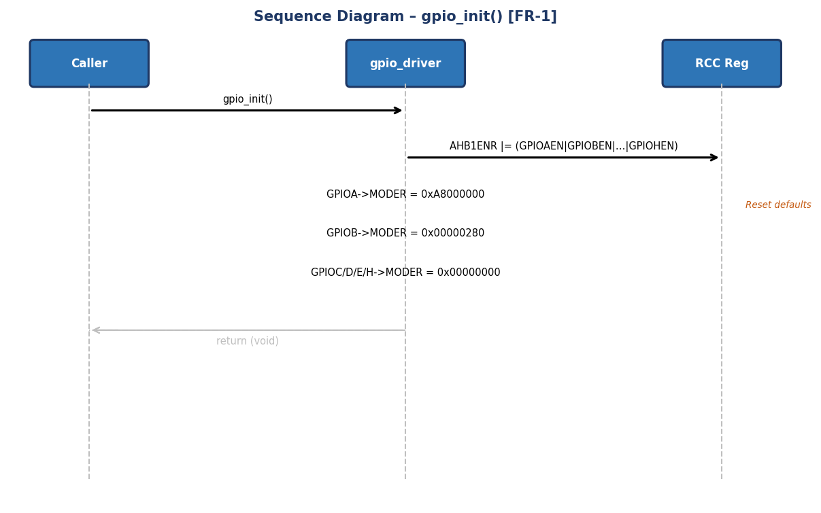
Fig. 9 — Sequence Diagram: gpio_init() [FR-1]

The sequence diagram for gpio_init() shows that the function takes no parameters and returns no status value (void). The only external actor is the Caller, who sends a single message to gpio_driver. Internally, the function performs a single OR-write to RCC->AHB1ENR to enable all six port clocks (GPIOAEN, GPIOBEN, GPIOCEN, GPIODEN, GPIOEEN, and GPIOHEN) simultaneously. It then sends six consecutive writes to each port's MODER register to restore their RM0383 post-reset default values. There is no error branch because the operation always succeeds at the hardware level. This function must be called before any other driver function to ensure peripheral clocks are active before the first GPIO register access.
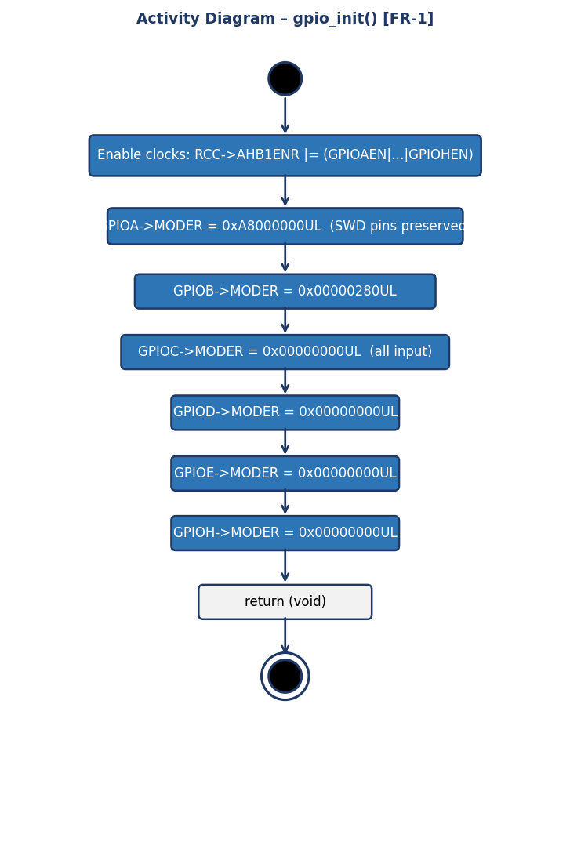
Fig. 10 — Activity Diagram: gpio_init() [FR-1]

The activity diagram for gpio_init() shows a purely linear sequence of seven actions with no decision nodes. The flow begins at the start node (solid black circle) and proceeds directly to enabling clocks with a single OR instruction to AHB1ENR. Each port then receives its reset value: GPIOA gets 0xA8000000 to preserve PA13 and PA15 used by the SWD debug interface; GPIOB receives 0x00000280; and ports C, D, E, and H receive 0x00000000, placing all their pins in safe input mode. The absence of decision diamonds confirms that gpio_init() is a straight-line configuration function: it validates no arguments because it has none, and returns void after the last register write.

gpio_initPort() — FR-2: Port Initialization
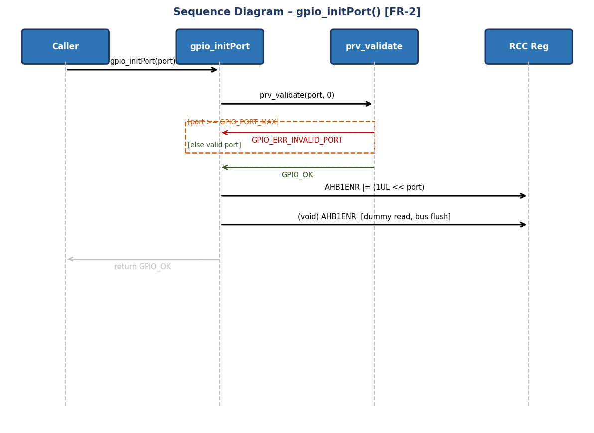
Fig. 11 — Sequence Diagram: gpio_initPort() [FR-2]

The sequence diagram for gpio_initPort() shows three participants: the Caller, the gpio_initPort function, and the RCC register. The first action upon receiving the port argument is to delegate validation to prv_validate(). The alt combined fragment splits the flow into two paths: if port >= GPIO_PORT_MAX, GPIO_ERR_INVALID_PORT is returned immediately without touching any hardware register, satisfying NFR-2 (error handling). On the valid path, the function writes the port's corresponding bit in RCC->AHB1ENR using the expression (1UL << port), which exploits the fact that GPIO_Port_t values align with the register's bit positions. Immediately after, it performs a dummy read of the same register to flush the AHB bus pipeline and ensure the clock is stable before the next GPIO register access.
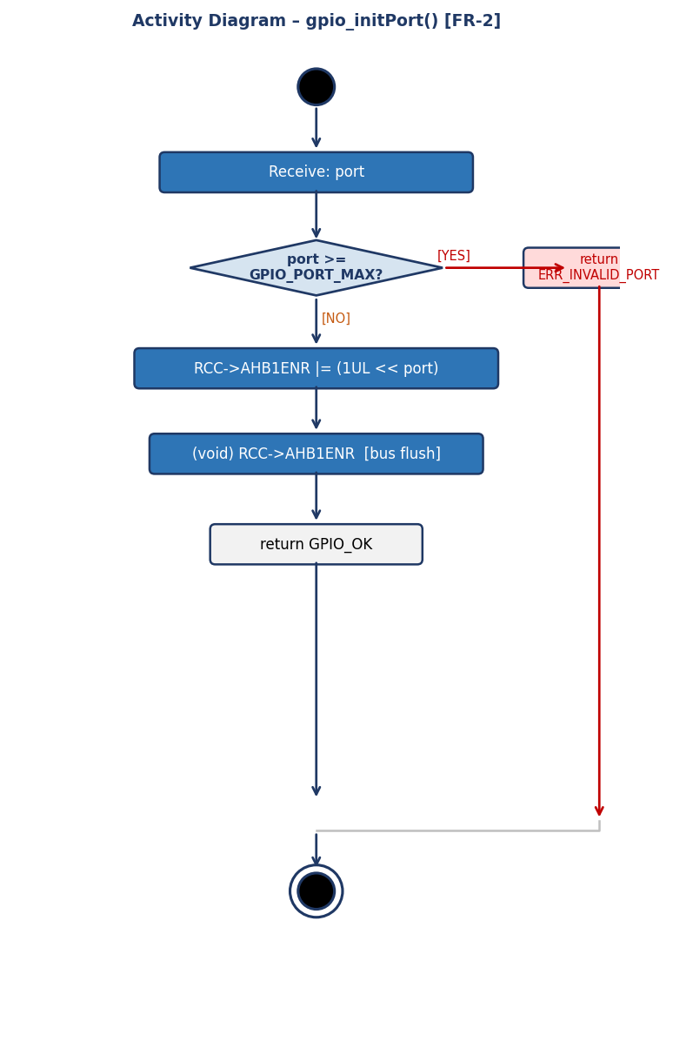
Fig. 12 — Activity Diagram: gpio_initPort() [FR-2]

The activity diagram for gpio_initPort() presents the first decision node of the GPIO driver: verifying that the port is valid (port >= GPIO_PORT_MAX). The right-hand branch in red represents the error path; it returns GPIO_ERR_INVALID_PORT and terminates. If validation passes, the flow descends to the AHB1ENR bit-write using a single-bit OR operation (1UL << port), enabling only the requested port's clock without affecting the others. The next action is the AHB1ENR dummy read: this operation discards the read value but forces the AHB bus to complete the preceding write before execution continues, preventing bus-not-ready faults on the first MODER register access of the newly enabled port. Both branches converge at the end node.

gpio_setPin() — FR-4: Atomic Set HIGH
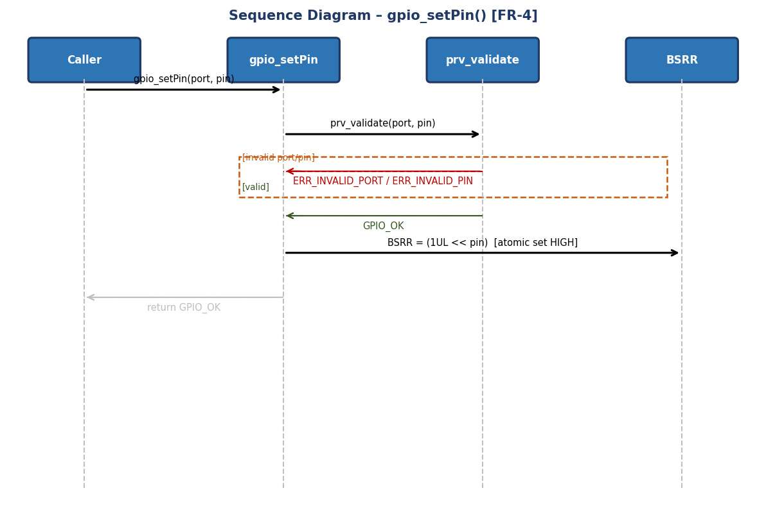
Fig. 13 — Sequence Diagram: gpio_setPin() [FR-4]

The sequence diagram for gpio_setPin() illustrates the atomic set operation of the GPIO driver. The function receives port and pin from the caller and delegates validation to prv_validate(); the alt fragment shows that any invalid argument produces the corresponding error code (GPIO_ERR_INVALID_PORT or GPIO_ERR_INVALID_PIN) without accessing hardware. On the valid path, the function writes directly to the port's BSRR register: the expression (1UL << pin) places a 1 in bits [15:0] of the register, which are the set bits. The STM32 BSRR register is write-only and processes both set and clear in a single 32-bit instruction, guaranteeing a bus-cycle-level atomic operation that can never produce an intermediate state or be interrupted by an ISR modifying the same pin.

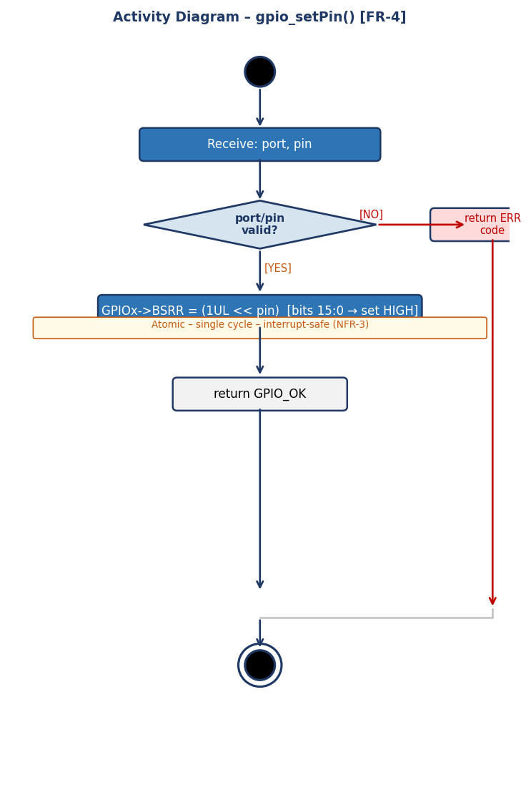
Fig. 14 — Activity Diagram: gpio_setPin() [FR-4]

The activity diagram for gpio_setPin() shows the validate-then-act pattern shared by all output control functions. After the start node, the decision diamond evaluates whether port and pin are in range. The error branch (red) returns the corresponding code. The valid branch (green) reaches the single hardware action: write (1UL << pin) to GPIOx->BSRR bits [15:0]. The orange note below that action highlights that the operation is single-cycle and interrupt-safe (NFR-3): since BSRR is a dedicated set/reset register, there is no need to read the current pin state or disable interrupts, unlike the read-modify-write sequence that the ODR register would require.

gpio_clearPin() — FR-5: Atomic Clear LOW
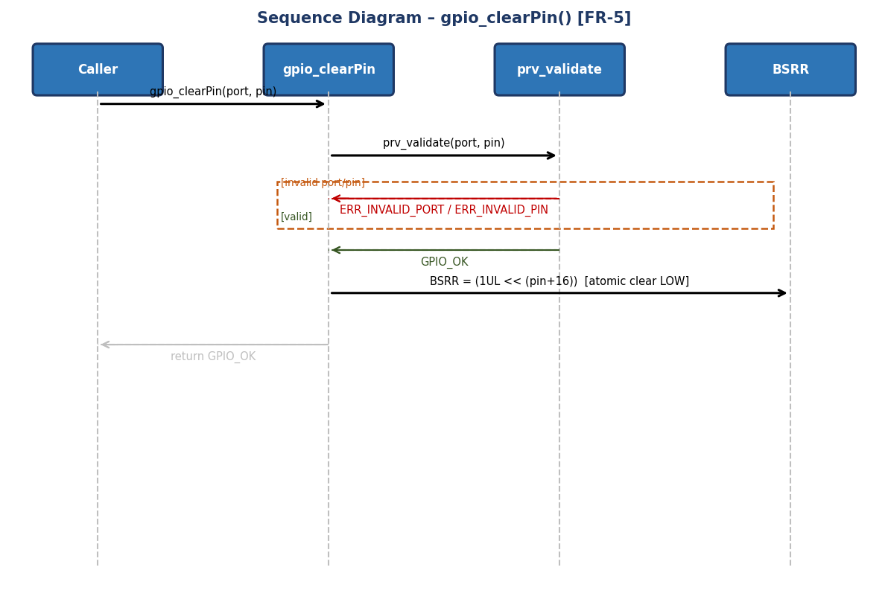
Fig. 15 — Sequence Diagram: gpio_clearPin() [FR-5]

The sequence diagram for gpio_clearPin() is symmetric to that of gpio_setPin(), but operates on the upper half of the BSRR register. After successful validation by prv_validate(), the function writes the expression (1UL << (pin + 16U)) to the BSRR register. Bits [31:16] of BSRR are the reset bits: writing a 1 at position pin+16 forces that pin low atomically in hardware. This separation of set bits (positions 0–15) and reset bits (positions 16–31) within the same register is why both operations are fully interrupt-safe: an ISR calling gpio_setPin() on the same pin during gpio_clearPin() execution will not produce an indeterminate state.

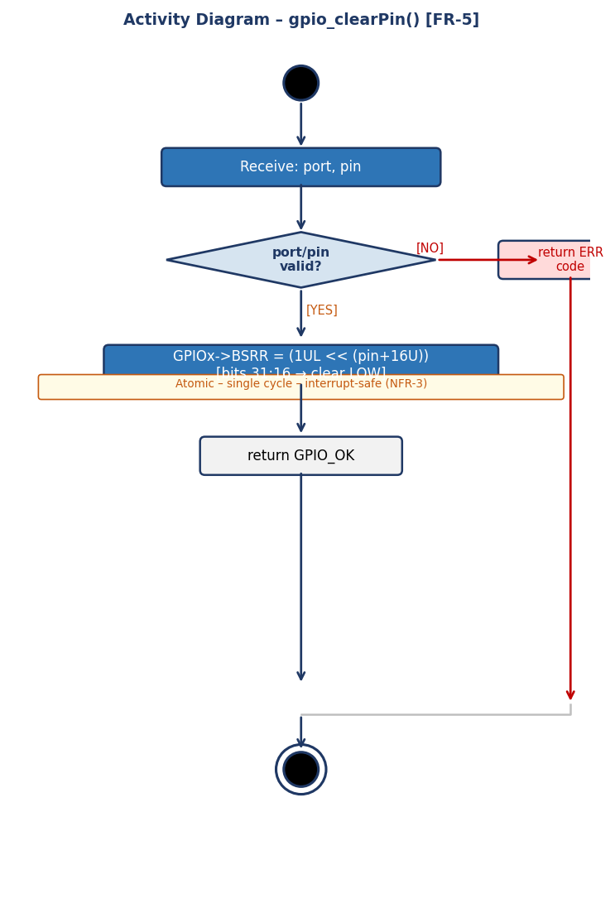
Fig. 16 — Activity Diagram: gpio_clearPin() [FR-5]

The activity diagram for gpio_clearPin() follows exactly the same structure as that of gpio_setPin(): start node, port/pin validation diamond, red error branch, and valid branch. The only visible difference is in the hardware action: the expression written to the BSRR register is (1UL << (pin + 16U)), targeting bits [31:16] of the reset channel. The diagram visually confirms that gpio_setPin() and gpio_clearPin() are dual operations: they share the same validation structure and the same BSRR destination register, differing only in the bit offset that activates the hardware. The orange atomicity note is identical, reinforcing that NFR-3 is satisfied in both functions the same way.

gpio_togglePin() — FR-6: XOR Invert
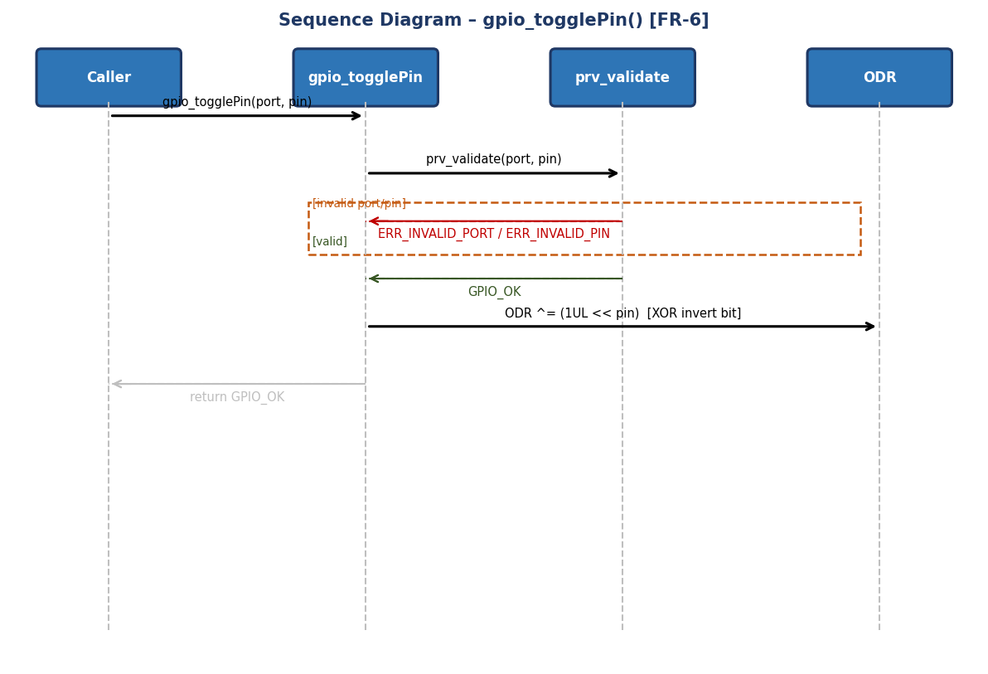
Fig. 17 — Sequence Diagram: gpio_togglePin() [FR-6]

The sequence diagram for gpio_togglePin() shows that, unlike gpio_setPin() and gpio_clearPin(), this function operates on the ODR (Output Data Register) rather than BSRR. After successful validation, the function sends the XOR operation to the ODR register: (ODR ^= 1UL << pin). This inverts the pin bit regardless of its current state. The diagram includes two hardware response branches to illustrate the outcome: if the bit was HIGH it becomes LOW, and if it was LOW it becomes HIGH. Although ODR is not atomic in the BSRR sense (it requires read-modify-write), it is safe to use for toggles in single-threaded contexts such as the main loop, where ISRs do not modify the same pin.

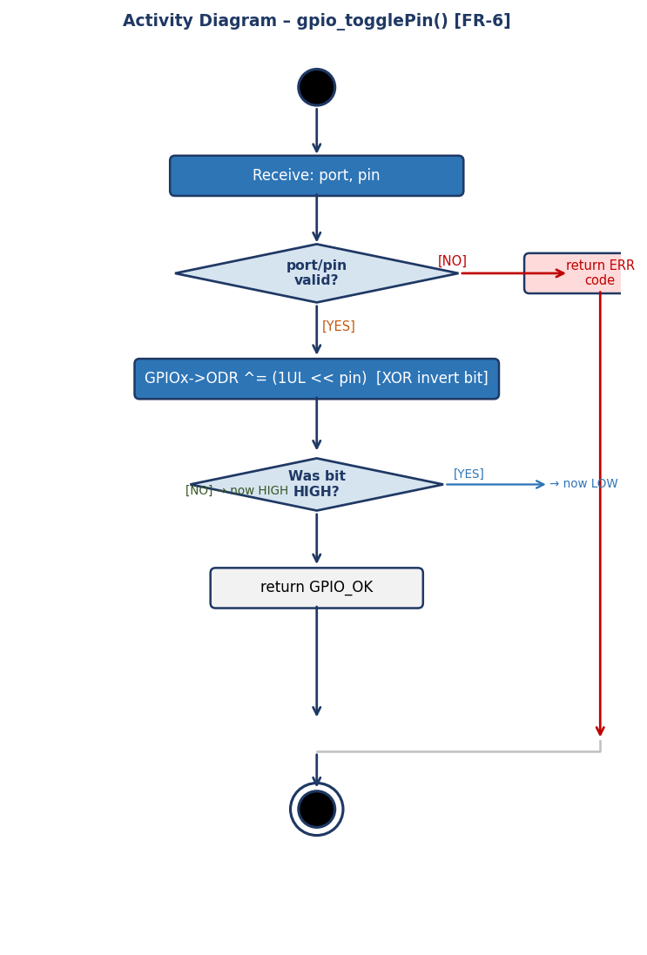
Fig. 18 — Activity Diagram: gpio_togglePin() [FR-6]

The activity diagram for gpio_togglePin() adds an extra decision diamond compared to the set/clear functions — not for validation, but to show the logical branching of the XOR result. After the action (ODR ^= 1UL << pin), the diamond asks 'Was bit HIGH?': if it was HIGH it is now LOW (right blue branch), if it was LOW it is now HIGH (left green branch). Both paths converge before the GPIO_OK return node, confirming that the outcome is always successful regardless of the pin's prior state. This diagram clearly illustrates why gpio_togglePin() does not require the caller to know the current pin state: the XOR operation determines and inverts it internally in a single write to the ODR register.

gpio_readPin() — FR-7: Input Read
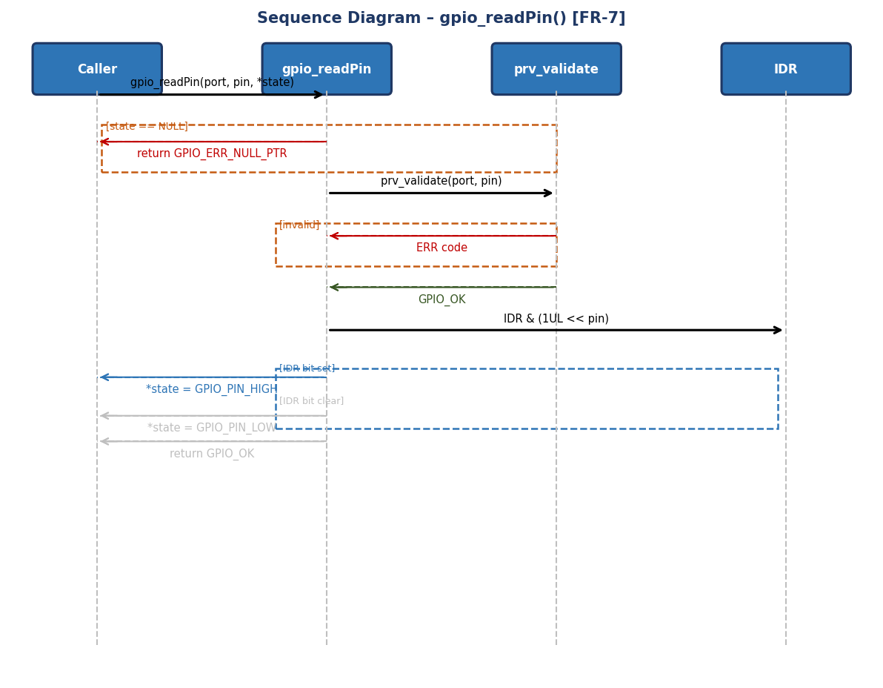
Fig. 19 — Sequence Diagram: gpio_readPin() [FR-7]

The sequence diagram for gpio_readPin() is the most complex in the driver because it combines two independent validations before accessing hardware. The first alt fragment checks whether the state pointer is NULL: if so it returns GPIO_ERR_NULL_PTR immediately without calling prv_validate(), because writing the result through a null pointer would trigger a Cortex-M4 HardFault. The second validation checks port and pin via prv_validate(). Only if both pass does the function read the IDR register with the mask (1UL << pin) and write the result to *state: GPIO_PIN_HIGH if the bit is set, GPIO_PIN_LOW otherwise. The diagram explicitly shows that the write to *state is the only interaction with caller memory, and that GPIO_OK is returned together with the digital pin state.

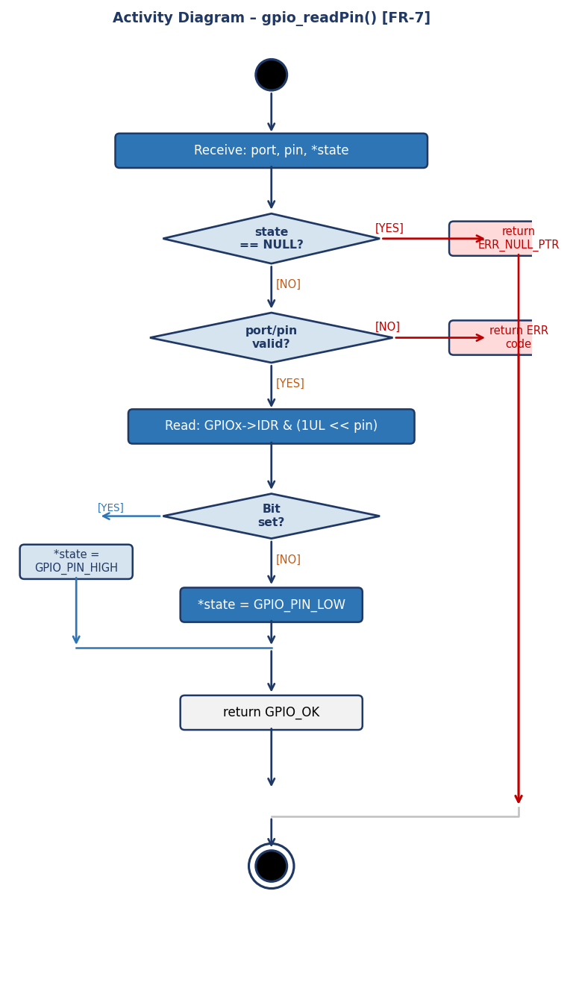
Fig. 20 — Activity Diagram: gpio_readPin() [FR-7]

The activity diagram for gpio_readPin() presents the driver's longest validation chain: three decision nodes before reaching hardware. The first checks state == NULL, the second verifies port and pin via prv_validate(), and the third evaluates the IDR register bit. The error branches (red) of the first two nodes exit to the right and merge before the end node. The successful read branch descends to the 'Bit set?' diamond: if the IDR bit for the target pin is 1, the flow goes left and writes GPIO_PIN_HIGH to *state; otherwise it descends and writes GPIO_PIN_LOW. Both paths converge at the GPIO_OK return node. The validation chain guarantees that hardware is never accessed with invalid arguments and that no write to a null pointer occurs.

gpio_setAlternateFunction() — FR-8: Alternate Function
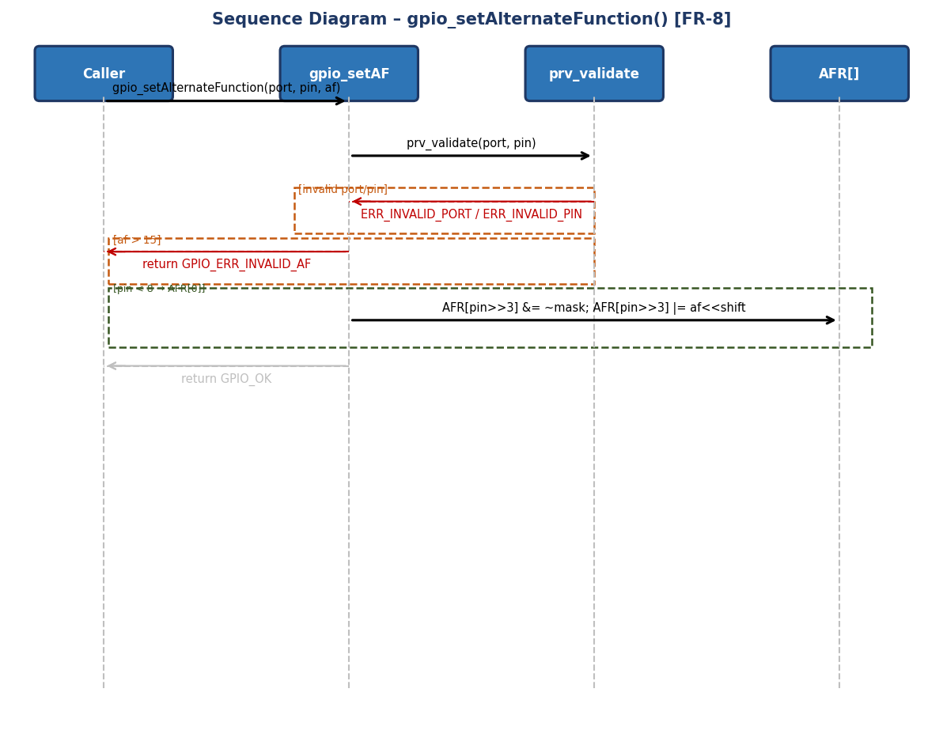
Fig. 21 — Sequence Diagram: gpio_setAlternateFunction() [FR-8]
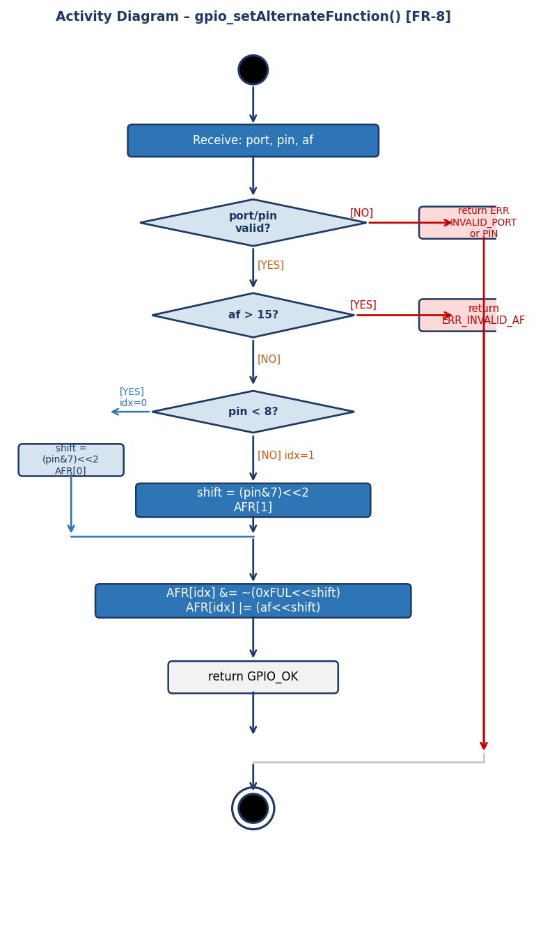
The sequence diagram for gpio_setAlternateFunction() shows the driver's most extensive validation chain: first prv_validate() checks port and pin, then an explicit guard rejects af values greater than 15, returning GPIO_ERR_INVALID_AF. With all three arguments valid, the function selects the correct AFR bank: AFR[0] for pins 0–7 and AFR[1] for pins 8–15 (using idx = pin >> 3). The field offset within the register is shift = (pin & 7) << 2, which positions the 4-bit alternate function field at its exact location. The write operation applies a clear mask (AFR[idx] &= ~(0xF << shift)) followed by an OR with the af value (AFR[idx] |= af << shift), leaving the 4-bit fields of neighboring pins untouched.
Fig. 22 — Activity Diagram: gpio_setAlternateFunction() [FR-8]

The activity diagram for gpio_setAlternateFunction() contains four decision nodes, the highest count of any function in the driver. The first two validate port/pin and af respectively; their error branches (red) converge at the end node. The third decides which AFR bank to use: if pin < 8 it uses AFR[0] with index 0 (left blue branch), otherwise it uses AFR[1] with index 1 (right green branch). Both branches converge at the write action, which performs a two-step read-clear-set: first clearing the 4-bit field with an AND mask, then writing the new alternate function value with an OR. This two-step pattern ensures that only the target pin's 4-bit field is modified, leaving the alternate function assignments of neighboring pins in the same AFR register completely untouched. The function returns GPIO_OK upon completion.

3.3. GPIO Driver
The GPIO driver is a hardware abstraction module written in C that targets the STM32F411RE microcontroller (RM0383). It provides a clean, validated API that allows upper-layer modules (LED driver, Button driver, and application code) to control any GPIO pin without accessing hardware registers directly. The driver complies with SRS-GPIO_Driver v1.0 and implements Functional Requirements FR-1 through FR-8, as documented by the sequence and activity diagrams in Section 3.2.1 (Figs. 9–22).
Internal Data Structures
The driver exposes no mutable global state. All hardware state is held in the STM32F411RE peripheral registers (GPIO_TypeDef, RCC_TypeDef) mapped at fixed AHB1 base addresses and accessed through the CMSIS device header stm32f4xx.h. Two private (static) helper functions encapsulate the internal lookup logic and are never visible to callers:
prv_getPort(GPIO_Port_t port) — Returns a GPIO_TypeDef pointer corresponding to the requested port enum value. It uses a switch statement over GPIO_PORT_A through GPIO_PORT_H and returns a null pointer for any unrecognized value, which acts as an additional runtime safeguard inside the driver body.
prv_validate(GPIO_Port_t port, uint8_t pin) — Performs boundary checks on both arguments. It returns GPIO_ERR_INVALID_PORT if port >= GPIO_PORT_MAX, GPIO_ERR_INVALID_PIN if pin > 15, and GPIO_OK otherwise. Every public function except gpio_init() calls this helper before touching any hardware register, satisfying NFR-2 (error handling).
Initialization Flow
System initialization is a two-stage process. In the first stage, gpio_init() (FR-1, Fig. 9–10) enables all six GPIO peripheral clocks in a single OR-write to RCC->AHB1ENR: RCC->AHB1ENR |= (GPIOAEN | GPIOBEN | GPIOCEN | GPIODEN | GPIOEEN | GPIOHEN). It then sets each port's MODER register to its RM0383 post-reset default: GPIOA = 0xA8000000 (preserving PA13/PA15 for SWD), GPIOB = 0x00000280, and all others = 0x00000000. Because gpio_init() always succeeds it returns void with no error checking required from the caller.
In the second stage, gpio_initPort() (FR-2, Fig. 11–12) can enable the clock for any individual port on demand using RCC->AHB1ENR |= (1UL << port). The GPIO_Port_t enumeration values are deliberately aligned with the AHB1ENR bit positions so that the bit-shift expression is both correct and self-documenting. A dummy read of RCC->AHB1ENR after the write flushes the AHB bus pipeline, preventing bus-not-ready faults on the immediately following MODER access.
Pin Mode Configuration
gpio_setPinMode() (FR-3) configures four independent hardware fields for one pin. It applies a read-clear-set pattern to each field, modifying only the 2-bit or 1-bit slot that belongs to the target pin and leaving all adjacent pins unaffected. The four register writes are performed in this fixed order:
1. MODER[2n+1:2n] — sets the pin operating mode (INPUT=00, OUTPUT=01, ALT_FN=10, ANALOG=11). 2. OTYPER[n] — selects push-pull (0) or open-drain (1) output driver. 3. OSPEEDR[2n+1:2n] — controls the output slew rate from LOW (~2 MHz) to VHIGH (~100 MHz). 4. PUPDR[2n+1:2n] — configures internal pull resistors (NONE=00, PULL_UP=01, PULL_DOWN=10).
Validation occurs before any register write: the cfg pointer is checked for NULL first (returns GPIO_ERR_NULL_PTR), then prv_validate() checks port and pin range. As shown in the sequence diagram Fig. 4 and activity diagram Fig. 5, both error paths terminate before any hardware is touched.
Pin Output Control
Three functions control pin output state. gpio_setPin() (FR-4, Fig. 13–14) drives a pin HIGH by writing (1UL << pin) to BSRR bits [15:0]. gpio_clearPin() (FR-5, Fig. 15–16) drives a pin LOW by writing (1UL << (pin + 16U)) to BSRR bits [31:16]. Both operations use the BSRR (Bit Set/Reset Register), which is a dedicated write-only register that performs set or reset in a single bus cycle. This guarantees atomicity at the hardware level without disabling interrupts, satisfying NFR-3 (real-time safe). An ISR modifying the same pin concurrently will not produce an indeterminate state because each BSRR write independently activates only its assigned hardware channel.
gpio_togglePin() (FR-6, Fig. 17–18) inverts the current state of a pin by performing ODR ^= (1UL << pin), an XOR on the Output Data Register. Unlike BSRR, ODR requires a read-modify-write sequence, so it is not atomic by hardware guarantee. However, it is safe to use in single-threaded contexts or in sections where the same pin is not shared with ISRs. The activity diagram (Fig. 18) shows that the function returns GPIO_OK regardless of the prior pin state — the XOR determines and inverts the value internally without the caller needing to know the current state.
Pin Read
gpio_readPin() (FR-7, Fig. 19–20) reads the logical level on a pin by sampling the IDR (Input Data Register). The result is written to the caller-provided pointer *state as either GPIO_PIN_HIGH or GPIO_PIN_LOW. The function implements the driver's most defensive validation chain: it checks for a NULL state pointer before calling prv_validate(), because a NULL write would trigger a Cortex-M4 HardFault before any error code could be returned. After both validations pass, it evaluates IDR & (1UL << pin): a non-zero result writes GPIO_PIN_HIGH, zero writes GPIO_PIN_LOW. The IDR register reflects the actual voltage on the pin, so it correctly reads the state of both input-configured and output-configured pins.
Alternate Function Configuration
gpio_setAlternateFunction() (FR-8, Fig. 21–22) assigns one of the 16 STM32 alternate functions (AF0–AF15) to a pin. The STM32F411RE stores these assignments in two 32-bit Alternate Function Registers per port: AFR[0] for pins 0–7 and AFR[1] for pins 8–15, each pin occupying a 4-bit field. The driver computes the bank index as idx = pin >> 3 and the field offset as shift = (pin & 0x7) << 2. It then applies a two-step read-clear-set: AFR[idx] &= ~(0xFUL << shift) to clear the 4-bit field, followed by AFR[idx] |= ((uint32_t)af << shift) to write the new value. This pattern guarantees that neighboring pins' alternate function assignments are never disturbed. An additional guard rejects af > 15 with GPIO_ERR_INVALID_AF before any register access.
Error Handling and Safety Model
All public functions except gpio_init() return a GPIO_Status_t error code (NFR-2). The error handling strategy follows a fail-fast, fail-safe approach: argument validation happens at the very beginning of each function, before any hardware register is modified. This ensures that the GPIO peripheral is never left in a partially configured state due to an invalid argument. The validation hierarchy is: (1) NULL pointer check on output parameters, (2) port range check via prv_validate(), (3) pin range check via prv_validate(), (4) function-specific checks (af > 15 for gpio_setAlternateFunction). Error codes are negative integers so they can be distinguished from GPIO_OK = 0 by a simple comparison. Refer to Section 4.2 for the complete error code reference.
Design Decisions and Rationale
The choice to use BSRR for gpio_setPin() and gpio_clearPin() instead of directly writing ODR was driven by NFR-3 (real-time safe, no blocking calls). BSRR guarantees interrupt safety at the hardware level with no software overhead. The use of a dummy read after gpio_initPort()'s clock enable is a mandatory workaround for the STM32 AHB bus behavior documented in RM0383 Section 6.3.11: a peripheral clock must complete propagation before the first register access. The enumeration values in GPIO_Port_t were deliberately chosen to match AHB1ENR bit positions, allowing gpio_initPort() to use a direct bit-shift rather than a lookup table, satisfying NFR-1 (lightweight, no HAL dependency).

4. Application Programming Interfaces
4.1. Data Types and Macros
- GPIO_Status_t: Return type enumeration for all public functions (except gpio_init()). GPIO_OK=0 on success; negative codes on failure.
- GPIO_PinCfg_t: Configuration structure passed by pointer to gpio_setPinMode(). Contains mode, pull, otype, and speed fields.
Member Name | Type | Notes/Definition
mode | GPIO_Mode_t | Pin operating mode (input, output, alternate function, analog)
pull | GPIO_Pull_t | Internal pull resistor (none, pull-up, pull-down)
otype | GPIO_OType_t | Output driver type (push-pull or open-drain)
speed | GPIO_Speed_t | Output slew rate (low, medium, high, very high)
- GPIO_Port_t: Enum identifying the target port. Values match AHB1ENR bit positions. Members: GPIO_PORT_A=0, GPIO_PORT_B=1, GPIO_PORT_C=2, GPIO_PORT_D=3, GPIO_PORT_E=4, GPIO_PORT_H=7, GPIO_PORT_MAX=8 (sentinel).
- GPIO_Mode_t: MODER 2-bit encoding: GPIO_MODE_INPUT=0x00, GPIO_MODE_OUTPUT=0x01, GPIO_MODE_ALT_FN=0x02, GPIO_MODE_ANALOG=0x03.
- GPIO_Pull_t: GPIO_PULL_NONE=0x00, GPIO_PULL_UP=0x01, GPIO_PULL_DOWN=0x02.
- GPIO_OType_t: GPIO_OTYPE_PUSH_PULL=0x00, GPIO_OTYPE_OPEN_DRAIN=0x01.
- GPIO_Speed_t: GPIO_SPEED_LOW=0x00 (~2MHz), GPIO_SPEED_MEDIUM=0x01 (~25MHz), GPIO_SPEED_HIGH=0x02 (~50MHz), GPIO_SPEED_VHIGH=0x03 (~100MHz).
- GPIO_PinState_t: GPIO_PIN_LOW=0, GPIO_PIN_HIGH=1. Returned by gpio_readPin().

Register Map Structures
The driver interacts with six hardware register structures defined in the CMSIS header stm32f4xx.h. These structures map directly onto the STM32F411RE memory map and are accessed through fixed peripheral base addresses. No copies or shadows of these registers are maintained in software. The table below summarizes the registers used by the driver, their addresses (from RM0383), access type, and the driver functions that use them.
Register | Offset | Access | Used by Function(s) | Purpose in Driver
RCC->AHB1ENR | 0x40023830 | R/W | gpio_init(), gpio_initPort() | Enable GPIO peripheral clocks; bit position matches GPIO_Port_t enum value.
GPIOx->MODER | 0x00 | R/W | gpio_init(), gpio_setPinMode() | 2-bit field per pin: sets INPUT(00), OUTPUT(01), ALT_FN(10), ANALOG(11) mode.
GPIOx->OTYPER | 0x04 | R/W | gpio_setPinMode() | 1-bit per pin: selects push-pull (0) or open-drain (1) output driver type.
GPIOx->OSPEEDR | 0x08 | R/W | gpio_setPinMode() | 2-bit field per pin: controls output slew rate (LOW/MEDIUM/HIGH/VHIGH).
GPIOx->PUPDR | 0x0C | R/W | gpio_setPinMode() | 2-bit field per pin: enables internal pull-up (01) or pull-down (10) resistors.
GPIOx->IDR | 0x10 | Read-only | gpio_readPin() | 16-bit input data register; bit n reflects the current logic level on pin n.
GPIOx->ODR | 0x14 | R/W | gpio_togglePin() | 16-bit output data register; XOR-written to invert output state (read-modify-write).
GPIOx->BSRR | 0x18 | Write-only | gpio_setPin(), gpio_clearPin() | Bits[15:0]=set, Bits[31:16]=reset; single-cycle atomic write, interrupt-safe.
GPIOx->AFR[0] | 0x20 | R/W | gpio_setAlternateFunction() | 4-bit fields for pins 0–7; selects AF0–AF15 for each pin (idx = pin >> 3 = 0).
GPIOx->AFR[1] | 0x24 | R/W | gpio_setAlternateFunction() | 4-bit fields for pins 8–15; selects AF0–AF15 for each pin (idx = pin >> 3 = 1).

GPIO_TypeDef Structure (CMSIS)
The GPIO_TypeDef structure from stm32f4xx.h maps the complete register set of one GPIO port at consecutive 32-bit word offsets. The driver accesses only the members listed in the register map above. The LCKR (lock register) and the reserved fields are never accessed by this driver.
Member | Type | Offset | Description
MODER | uint32_t | +0x00 | Mode register — 2 bits per pin (16 pins = 32 bits).
OTYPER | uint32_t | +0x04 | Output type — 1 bit per pin; upper 16 bits reserved.
OSPEEDR | uint32_t | +0x08 | Output speed — 2 bits per pin.
PUPDR | uint32_t | +0x0C | Pull-up/pull-down — 2 bits per pin.
IDR | uint32_t | +0x10 | Input data — 16 lower bits read actual pin levels.
ODR | uint32_t | +0x14 | Output data — 16 lower bits drive output pins.
BSRR | uint32_t | +0x18 | Bit set/reset — write-only; [15:0]=set, [31:16]=reset.
LCKR | uint32_t | +0x1C | Lock register — not used by this driver.
AFR[2] | uint32_t[2] | +0x20–0x24 | Alternate function — AFR[0] pins 0–7, AFR[1] pins 8–15.

4.2. Error Codes
The GPIO driver public API uses GPIO_Status_t as a unified return type for all functions except gpio_init(), which returns void because it always succeeds at the hardware level. GPIO_OK (value 0) is returned on successful completion. All error codes are defined as negative integers, making it trivial for callers to detect failure with a simple comparison (status != GPIO_OK or status < 0), satisfying NFR-2. Errors are returned immediately upon detection — no hardware registers are modified after an error is detected. The table below lists all defined error codes, their integer values, the functions that can return them, and the root cause condition that triggers each one.
Code | Integer Value | Returned By | Trigger Condition
GPIO_OK | 0 | All functions (except gpio_init()) | Operation completed successfully. All arguments valid; hardware write performed.
GPIO_ERR_INVALID_PORT | -1 | gpio_initPort(), gpio_setPinMode(), gpio_setPin(), gpio_clearPin(), gpio_togglePin(), gpio_readPin(), gpio_setAlternateFunction() | The port argument is >= GPIO_PORT_MAX (value 8). Port H has enum value 7; values 5, 6, and >= 8 are invalid.
GPIO_ERR_INVALID_PIN | -2 | gpio_setPinMode(), gpio_setPin(), gpio_clearPin(), gpio_togglePin(), gpio_readPin(), gpio_setAlternateFunction() | The pin argument is > 15U. Valid pin range is 0–15 for all STM32F4 GPIO ports.
GPIO_ERR_INVALID_MODE | -3 | Reserved — not returned by current implementation. | Reserved for future use. Defined to maintain a contiguous, stable error code space for future mode-specific validation.
GPIO_ERR_NULL_PTR | -4 | gpio_setPinMode(), gpio_readPin() | A required pointer argument is NULL. gpio_setPinMode() checks cfg == NULL; gpio_readPin() checks state == NULL. Writing through a null pointer causes a Cortex-M4 HardFault.
GPIO_ERR_INVALID_AF | -5 | gpio_setAlternateFunction() | The af argument is > 15U. The STM32F411RE supports alternate functions AF0–AF15 only; values above 15 have no hardware definition.

4.3. Function Definitions
gpio_init
Function Name | gpio_init
Syntax | void gpio_init(void)
Parameters (in) | N/A | This function takes no input parameters.
Parameters (inout) | N/A | This function has no input/output parameters.
Parameters (out) | N/A | This function has no output parameters.
Return value | void | Always succeeds; returns no status.
Description | Initializes the GPIO subsystem (FR-1). Enables clocks for ports A,B,C,D,E,H via single OR-write to RCC->AHB1ENR. Sets each port MODER to RM0383 reset default: GPIOA=0xA8000000UL, GPIOB=0x00000280UL, others=0x00000000UL. Must be called first.
Constraints | Does not configure OTYPER, PUPDR, OSPEEDR (retain hardware reset defaults).
Available via | gpio_driver.h
gpio_initPort
Function Name | gpio_initPort
Syntax | GPIO_Status_t gpio_initPort(GPIO_Port_t port)
Parameters (in) | port | GPIO_Port_t - Identifies the GPIO port whose peripheral clock shall be enabled. Valid values: GPIO_PORT_A through GPIO_PORT_H.
Parameters (inout) | N/A | This function has no input/output parameters.
Parameters (out) | N/A | This function has no output parameters.
Return value | GPIO_Status_t | GPIO_OK on success. GPIO_ERR_INVALID_PORT if port >= GPIO_PORT_MAX.
Description | Enables the clock for a single GPIO port (FR-2). Writes (1UL << port) to RCC->AHB1ENR. Performs a dummy read of RCC->AHB1ENR to flush the AHB bus before the next register access.
Constraints | GPIO_PORT_H maps to AHB1ENR bit 7 (non-contiguous). Dummy read prevents bus-not-ready faults.
Available via | gpio_driver.h
gpio_setPinMode
Function Name | gpio_setPinMode
Syntax | GPIO_Status_t gpio_setPinMode(GPIO_Port_t port, uint8_t pin, const GPIO_PinCfg_t *cfg)
Parameters (in) | port | GPIO_Port_t - Target GPIO port (GPIO_PORT_A through GPIO_PORT_H).
 | pin | uint8_t - Target pin number within the port. Valid range: 0 to 15.
 | cfg | const GPIO_PinCfg_t* - Pointer to a configuration structure containing mode, pull, otype, and speed fields. Must not be NULL.
Parameters (inout) | N/A | This function has no input/output parameters.
Parameters (out) | N/A | This function has no output parameters.
Return value | GPIO_Status_t | GPIO_OK. GPIO_ERR_NULL_PTR if cfg==NULL. GPIO_ERR_INVALID_PORT or GPIO_ERR_INVALID_PIN if out of range.
Description | Configures pin operating mode (FR-3) using read-clear-set on: (1) MODER bits[2n+1:2n] <- mode; (2) OTYPER bit[n] <- otype; (3) OSPEEDR bits[2n+1:2n] <- speed; (4) PUPDR bits[2n+1:2n] <- pull. Only target pin fields modified; adjacent pins unaffected.
Constraints | NULL checked before port/pin validation. All four cfg fields written unconditionally.
Available via | gpio_driver.h
gpio_setPin
Function Name | gpio_setPin
Syntax | GPIO_Status_t gpio_setPin(GPIO_Port_t port, uint8_t pin)
Parameters (in) | port | GPIO_Port_t - Target GPIO port (GPIO_PORT_A through GPIO_PORT_H).
 | pin | uint8_t - Target pin number. Valid range: 0 to 15. The corresponding BSRR set bit will be written.
Parameters (inout) | N/A | This function has no input/output parameters.
Parameters (out) | N/A | This function has no output parameters.
Return value | GPIO_Status_t | GPIO_OK. GPIO_ERR_INVALID_PORT or GPIO_ERR_INVALID_PIN if out of range.
Description | Atomically drives pin to logic HIGH (FR-4). Writes (1UL << pin) to BSRR bits[15:0]. Single-cycle; interrupt-safe without disabling interrupts (NFR-3).
Constraints | Pin must be configured as GPIO_MODE_OUTPUT via gpio_setPinMode().
Available via | gpio_driver.h
gpio_clearPin
Function Name | gpio_clearPin
Syntax | GPIO_Status_t gpio_clearPin(GPIO_Port_t port, uint8_t pin)
Parameters (in) | port | GPIO_Port_t - Target GPIO port (GPIO_PORT_A through GPIO_PORT_H).
 | pin | uint8_t - Target pin number. Valid range: 0 to 15. The corresponding BSRR reset bit (pin+16) will be written.
Parameters (inout) | N/A | This function has no input/output parameters.
Parameters (out) | N/A | This function has no output parameters.
Return value | GPIO_Status_t | GPIO_OK. GPIO_ERR_INVALID_PORT or GPIO_ERR_INVALID_PIN if out of range.
Description | Atomically drives pin to logic LOW (FR-5). Writes (1UL << (pin+16U)) to BSRR bits[31:16]. Same atomicity and interrupt-safety as gpio_setPin().
Constraints | Same output-mode requirement as gpio_setPin().
Available via | gpio_driver.h
gpio_togglePin
Function Name | gpio_togglePin
Syntax | GPIO_Status_t gpio_togglePin(GPIO_Port_t port, uint8_t pin)
Parameters (in) | port | GPIO_Port_t - Target GPIO port (GPIO_PORT_A through GPIO_PORT_H).
 | pin | uint8_t - Target pin number. Valid range: 0 to 15. The ODR bit for this pin will be XOR-inverted.
Parameters (inout) | N/A | This function has no input/output parameters.
Parameters (out) | N/A | This function has no output parameters.
Return value | GPIO_Status_t | GPIO_OK. GPIO_ERR_INVALID_PORT or GPIO_ERR_INVALID_PIN if out of range.
Description | Inverts current output state of pin (FR-6). Performs ODR ^= (1UL << pin). HIGH becomes LOW and vice versa.
Constraints | Non-atomic read-modify-write on ODR. Safe here since no ISR modifies the same port concurrently.
Available via | gpio_driver.h
gpio_readPin
Function Name | gpio_readPin
Syntax | GPIO_Status_t gpio_readPin(GPIO_Port_t port, uint8_t pin, GPIO_PinState_t *state)
Parameters (in) | port | GPIO_Port_t - Target GPIO port (GPIO_PORT_A through GPIO_PORT_H).
 | pin | uint8_t - Target pin number. Valid range: 0 to 15. The IDR bit for this pin will be sampled.
Parameters (inout) | N/A | This function has no input/output parameters.
Parameters (out) | state | GPIO_PinState_t* - Output pointer that receives the pin logic level. Set to GPIO_PIN_HIGH if IDR bit is 1, GPIO_PIN_LOW if 0. Must not be NULL.
Return value | GPIO_Status_t | GPIO_OK. GPIO_ERR_NULL_PTR if state==NULL. GPIO_ERR_INVALID_PORT/PIN if out of range.
Description | Reads current logic level from IDR (FR-7). If (IDR & (1UL<<pin)) != 0: *state = GPIO_PIN_HIGH; else *state = GPIO_PIN_LOW.
Constraints | NULL pointer check before port/pin validation. For output pins, IDR reflects actual pad voltage.
Available via | gpio_driver.h
gpio_setAlternateFunction
Function Name | gpio_setAlternateFunction
Syntax | GPIO_Status_t gpio_setAlternateFunction(GPIO_Port_t port, uint8_t pin, uint8_t af)
Parameters (in) | port | GPIO_Port_t - Target GPIO port (GPIO_PORT_A through GPIO_PORT_H).
 | pin | uint8_t - Target pin number. Valid range: 0 to 15. Determines which AFR register and 4-bit field to write.
 | af | uint8_t - Alternate function number. Valid range: 0 to 15. The correct AF number per peripheral is defined in the STM32F411RE datasheet, Table 9.
Parameters (inout) | N/A | This function has no input/output parameters.
Parameters (out) | N/A | This function has no output parameters.
Return value | GPIO_Status_t | GPIO_OK. GPIO_ERR_INVALID_PORT/PIN for bad args. GPIO_ERR_INVALID_AF if af > 15U.
Description | Configures alternate function for a pin (FR-8). Selects AFR[0] for pins 0-7 (idx=pin>>3) or AFR[1] for 8-15. Shift=(pin&7)<<2. Writes: AFR[idx] &= ~(0xF<<shift); AFR[idx] |= (af<<shift).
Constraints | Only sets AFR field. Caller must also configure pin as GPIO_MODE_ALT_FN via gpio_setPinMode(). AF number per peripheral found in STM32F411RE datasheet.
Available via | gpio_driver.h
4.4. Internal Function Definitions
prv_validate
Function Name | prv_validate
Syntax | static GPIO_Status_t prv_validate(GPIO_Port_t port, uint8_t pin)
Parameters (in) | port | GPIO_Port_t - GPIO port to validate. Must be strictly less than GPIO_PORT_MAX (value 8).
 | pin | uint8_t - Pin number to validate. Must be less than or equal to 15U.
Parameters (inout) | N/A | This function has no input/output parameters.
Parameters (out) | N/A | This function has no output parameters.
Return value | GPIO_Status_t | GPIO_OK if valid. GPIO_ERR_INVALID_PORT if port>=GPIO_PORT_MAX. GPIO_ERR_INVALID_PIN if pin>15U.
Description | Centralised argument validator called by every public function accepting port and pin. Port is checked first, then pin. Eliminates duplicated validation logic.
Constraints | Static in gpio_driver.c. Not part of the public API.
prv_getPort
Function Name | prv_getPort
Syntax | static GPIO_TypeDef *prv_getPort(GPIO_Port_t port)
Parameters (in) | port | GPIO_Port_t - Pre-validated GPIO port identifier. Should always be passed after a successful prv_validate() call.
Parameters (inout) | N/A | This function has no input/output parameters.
Parameters (out) | N/A | This function has no output parameters.
Return value | GPIO_TypeDef * | Pointer to CMSIS GPIO_TypeDef (GPIOA-GPIOH). Returns NULL for unknown values (defensive).
Description | Resolves GPIO_Port_t enum to hardware register base address via switch statement (GPIOA, GPIOB, GPIOC, GPIOD, GPIOE, GPIOH). Called after prv_validate() so NULL never dereferenced.
Constraints | Static in gpio_driver.c. Not part of the public API.

5. Future Enhancements
- Interrupt support: Add gpio_configInterrupt() and gpio_enableInterrupt() to configure EXTI lines for edge-triggered detection without polling.
- Port-wide configuration: Add gpio_initPortFull() to configure all 16 pins of a port in a single call using a configuration array.
- Portability layer: Abstract RCC and GPIO register definitions for reuse on other Cortex-M devices (STM32F0, STM32L4) without modifying driver logic.
- Unit test suite: Develop hardware-independent tests using mock register definitions to validate all driver functions and error paths on a host machine.

